 **ST. AGNES COLLEGE (AUTONOMOUS)**

**MANGALURU – 575002**



A PROJECT REPORT ON

**“ASHIRVAD MEDICAL STORE”**

Submitted to St. Agnes College (Autonomous), Mangalore

in partial fulfilment of the requirements

for the award of the degree in

**Bachelor of Computer Applications**

Carried out by

Lia John (Reg. No: 1851836)

Sahana (Reg. No: 1851808)

Manisha J Devadiga (Reg. No: 1851805)

**INTERNAL GUIDE EXTERNAL GUIDE**

*Mrs. Malavika Shetty Mr. Addappa*

Dept. of Computer Applications Code lab,

St. Agnes College (Autonomous), Mangalore

Mangalore

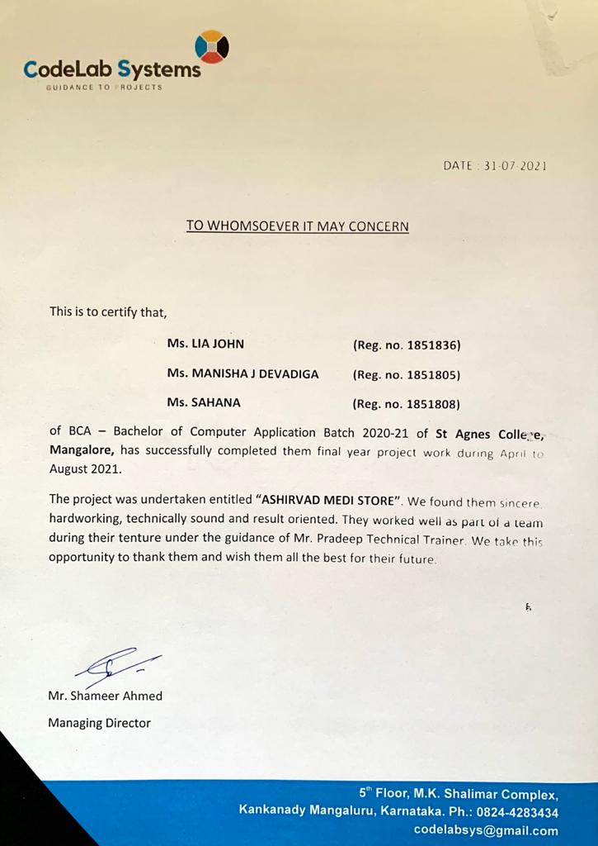

**DECLARATION**

We hereby declare that this project entitled as “Ashirvad Medical Store” was prepared by us during the year 2020-2021, in partial fulfilment of the requirements for the award of the degree in Bachelor of Computer Applications.

We also declare that this project is the result of our own efforts and has not been submitted to any other university for the award of any degree.

Lia John (Reg. No: 1851836)

Sahana (Reg. No: 1851808)

Manisha J Devadiga (Reg. No: 1851805)

Bachelor of Computer Applications

St. Agnes College (Autonomous),

Mangalore

Project Guide: Mr. Addappa

Place: Mangalore

**ACKNOWLEDGEMENT**

Working on the project “Ashirvad Medical store” was a source of inspiration and knowledge to us. A successful and satisfactory completion of any task is the outcome of invaluable aggregate contribution of people in the radial direction, explicitly and implicitly. We would therefore like to take this opportunity to express our gratitude to all those people without whose invaluable contribution wouldn’t have made this project successful.

We sincerely wish to thanks to Mrs. Malavika Shetty from the Department of Computer Applications for her unfailing support and constant guidance throughout the project work. We would also like to express our deep sense of appreciation to Mrs. Malavika Shetty the HOD of the Department of Computer Applications for her encouragement and support.

We express our sincere thanks to Mr. Addappa, a Software Developer at Codelab, for his guidance, proficiency, encouragement and commitment over our project without which we may not have completed our project successfully.

We would like to sincerely thank all the people directly or indirectly involved in this project, without whose help, the completion of this project would have been virtually impossible.

**INDEX**

|  |  |  |
| --- | --- | --- |
| **S. No.** | **DESCRIPTION** | **PAGE NO.** |
| 1 | Synopsis |  |
| 2 | Preamble |  |
| 3 | Software Requirements Specification |  |
| 4 | System Design |  |
| 5 | Database Design |  |
| 6 | Detailed Design |  |
| 7 | Testing |  |
| 8 | User Manual |  |
| 9 | Conclusion |  |
| 10 | Bibliography |  |

**SYNOPSIS**

**SYNOPSIS**

**Title of the Project:** Ashirvad Medi Store

**Introduction:** “Ashirvad Medi Store” is a website for a medical store that is used to make the owner’s business run better as well give them a more organized method to run their inventory. This website allows people to view their products online and place orders respectively. We have seen, especially in the times of COVID-19, how important the role of a medical store is, whether it’s to provide medicines or equipment or any other products. We see in the case of older customers or even patients, it can be difficult for them to go out and get their medications. This website makes it easier to place the order at home and have it delivered to your door step. The website has an option to upload prescriptions for drugs and also has an online payment method. This website allows the employees at Ashirvad Medicals to keep a record of the orders they receive online. In the case of inventory, the owner will have to manually enter the number of products in a pre-existing list that consists of all the products that the medical store provides. Implementing this project can make it extremely convenient for customers to order in the comfort of their homes.

**Objective:**

• It is user friendly for Pharmacists

• To reduce the burden of the pharmacist by managing all the sections of pharmacy

such as storing the necessary information about the drugs/products, to prepare bills

and to easily categorise the drugs/products.

• To improve the processing efficiency.

• To eliminate the waste of time.

• To remove resources such as paper for data saving.

• To make it easier for clients by introducing home delivery

• It is user friendly to the customers, making it easier to find products and place and

orders.

**Category:** Web based RDBMS

**Model Description:**

The first page consists of a carousel on ways to prevent COVID-19 and has advertisements. Under products, there are categories such as ayurveda, women care, health devices, baby care, home essentials, personal care, health and nutrition. The user gets brief information about the pharmacy. There’s also an option to upload a doctor’s prescription, a view cart option, an FAQ section and a contact us section. The customer can choose products based on the categories provided.

**Registration:**

The user can purchase a product only when he/she signs in. The admin and the manager can access the system and have control over it only after signing in.

**• Feature of admin:**

The admin adds, edit and can view the manager details of the store and has the ability view orders, payments, stock and feedback. They can also delete products. They have ability to check the expiry date and to do the necessary.

**• Feature of manager:**

The manager side interface is where the products are added, deleted, updated and viewed. The manager can view order, payment, stock, prescriptions and prescription bills. Prescription stock has a separate heading where the manager has to manually enter the stock.

**• Feature of user:**

The user can create an account and view all the products based on categories and view its description and prices and then add it to their cart and proceed with the payment. They are even able to add the doctor’s prescription. They can even edit their personal information.

**• Stocks:**

Stock keeps record of the products remaining and the price.

**• Billing:**

Can be done using card transactions or UPI pin, COD is available for the prescription medications.

**Software requirements:**

• Language: PHP

• Web components: HTML CSS Bootstrap

• Scripting language: JavaScript

• Operating systems: windows

• Text editor: sublime

• Database: MySQL

• Server: Apache

• Browser: Firefox or any other.

**Hardware requirements:**

• Processor: Intel dual core or above

• Processer speed: minimum 2ghz

• RAM: 2gb or above

• Hard Disk: minimum 40gb

**Innovativeness and usefulness:**

It’s useful for customers because the website allows them to take their time and look for products which they need. Products are sorted in categories which make it easier for customers to browse easily. The website also provides the option to insert prescriptions for prescription-required medications. The hassle of waiting in a queue is eliminated by a door step delivery service. ‘Ashirvad Medicals currently use spreadsheets to keep track of their supplies and the use of this project will help them to keep track of their supply demand. The pharmacist can easily add, delete and update the records in the database.

**Limitations:**

• There is no search bar for this website.

• There is no tracking system.

• No cash on delivery for OTC products.

• No automatic prescription billing.

• No automatic prescription stock maintenance.

• There is no alert given to the admin or manager when the product is expired or out of

stock.

**Future scope:**

• Develop an application for ‘Ashirvad Medicals’.

• In the future, the website can be used to tie up with medical labs for lab tests.

• Predict the medications/products you may want to view based on your previous

searches.

• Link up with the doctors who can help our customers get suggestions on their medications.

• Sending alerts for refills on long term-controlled medications.

• Create an e-wallet personalized for ‘Ashirvad Medi Store’ customers.

**PREAMBLE**

**PREAMBLE**

“Ashirwad Medical Store” is a website for a medical store developed using PHP and MySQL.

It is used to make the owner’s business run better as well as give them a more organized method to run their inventory. It is more convenient website where customer can quickly get medicines over the internet.

**SOFTWARE REQUIREMENTS SPECIFICATION**

**Software Requirement Specification**

1. **Introduction:**

A software requirements specification is a document that describes what the software will doand how it will be expected to perform. It is the basis for the entire project. The interaction between different customers and contractor is done because it’s necessary to fully understand needs of customers. An SRS minimizes the time and effort required by developers to achieve desired goals and also minimizes the development cost.

**1.1 Purpose:**

SRS lays the framework that every team involved in development will follow. It can also help you make decisions about your product’s lifecycle. SRS is a complete specification and description of requirements of software that needs to be fulfilled for successful development of software system. Using the SRS helps to ensure requirements are fulfilled. The requirements can be functional as well as non-requirements depending upon type of requirement. The purpose of this project is to create a client and customer friendly website for ‘Ashirvad Medicals’. It helps the client keep track of their product details and sales information. It creates a platform for customers to browse through products and place orders.

**1.2 Project Scope:**

The main objective of ‘Ashirvad Medi Store’ is to provide an online facility for ordering medications and products. The project is user friendly to its users and the client. The project allows customers to place orders at home and upload prescriptions for medications which make the pickup easier and faster. The project is basically updating the manual chemist inventory system to automated inventory system, so that it will be easy to manage their records in efficient and organized form.

**1.3 Definition, Acronyms, Abbreviations:**

* PHP -Hypertext Pre-processor
* HTML -Hyper Text Mark-up Language
* SRS -Software Requirement Specifications
* MySQL -My Structured Query Language
* GUI - Graphical User Interface
* DBMS - Database Management System
* RDBM - Relational Database Management
* DFD -Data Flow Diagram
* ERD - Entity Relationship Diagram
* API - Application Programming Interface
* WWW - World Wide Web
* HTTP - Hypertext Transfer Protocol
* TCP/IP - Transmission Control Protocol/Internet Protocol

**1.4 References:**

[www.w3schools.com](http://www.w3schools.com)

[www.tutorialspoint.com](http://www.tutorialspoint.com)

Learning PHP, MySQL, JavaScript and CSS: A Step-by-Step Guide to Creating toDynamic websites by Robin Nixon.

**1.5 Overview:**

The project “Ashirwad Medi Store” is developed to make the owner’s business run better as well as give them a more organized method to run their inventory.The admin can add, delete and update any product information. They can also keep track of their sales and customer account information. The customer can place orders by creating an account to view the menu and customize their orders. There’s also an option to upload doctor prescriptions and pay online.

1. **OVERALL DESCRIPTION:**

The overall description gives an overview of the requirements and other subsections. Subsections of the overall description are product perspective, design constraints, product functions, user characteristics and constraints, assumptions, and dependencies.

**2.1 Product perspective:**

The software described in this SRS is the software for a complete online medical store.The project aims to making placing orders at a pharmacy easier and hassle free.

**2.2 Product features:**

* The web application has a user-friendly interface and is easy to use.
* It can be accessed by customer, manager and admin at any time.
* Stores the details of the products, customers and orders.
* Enables the customers to view the products and order them online.
* Enables the customers to upload the doctor’s prescriptions.
* Reduces manual work and time consumption.
* Provides data security.
* Data loss is avoided.

**2.3 User Characteristics:**

**Admin module**

* The admin adds, edit and can view the manager details of the store and has the ability view orders, payments, stock and feedback.
* They can also delete products.
* They have ability to check the expiry date and to do the necessary.

**Manager module**

* The manager can add, delete, update and view the products.
* The manager can view order, payment, stock, prescriptions and prescription bills.
* Prescription stock has a separate heading where the manager has to manually enter the stock.

**Customer module**

* The user can create an account and view all the products based on categories.
* Can view the product description and price and then add it to their cart and proceed with the payment.
* They are even able to add the doctor’s prescription.
* They can edit their personal information
  1. **General Constraints:**
* Only registered customers can place order.
* Sales man cannot view customer orders without logging into the admin account.
* An error messages is raised when invalid performance occurred.

**2.5 Operating Environment**

These are the major components to run this software. The server needs following tools to run

the website:

* Apache Server
* MySQL Server

**2.6 Design and Implementation Constraints**

CO-1: The system’s design, code, and maintenance documentation shall confirm to the

Process Impact Development Standard, Version

CO-2: The system shall use the current corporate standard MySQL, database engine.

CO-3: All HTML code shall conform to the HTML 4.0 standard

CO-4: All scripts shall be written in PHP.

**2.7 Assumptions and Dependencies**

* Internet connection required.
* 24x7 uptime server connection required.
* It is assumed that the needed changes, to collect and store the data, will be made
* within the current application and database.
* One assumption about the product is that it will always be used on mobile phones that
* have enough performance.
* The user should have basic computer knowledge. They should be trained to handle the

features provided by the system.

1. **SPECIFIC REQUIREMENTS**

This section contains all of the functional and quality requirements of the system. It gives a detailed description of the system and all its features.

**3.1 External Interface Requirements:**

This section provides detailed description of all inputs into and outputs from the system. It also gives a description of the hardware, software and communication interfaces and provides basic prototypes of the user interface.

**3.1.1 User Interface:**

* The system provides a user-friendly GUI to the users.
* Using HTML for developing the user layout for the system
* PHP for creating all the validation and servers-side scripting functionality.
* CSS for designing web page of the system.
* Administrator: Admin is the main user of the website who controls complete website with full authority.
* Users: Users are the customers who can purchase products from the website.

**3.1.2 Hardware interface**

Processor: Intel dual core or above

Processor speed:2 GHz

RAM – 2 GB or above

Hard Disk – Minimum 40 GB

**3.1.3 Software Interface**

Operating System: Windows

User Interface Design: Html, CSS, Bootstrap

Server-Side Scripting: PHP

Backend: MySQL

Text Editor: Sublime Text 3

**3.1.4 Communication interface**

The project shall use the HTTP protocol for communication over the internet and for

the intranet communication will be through TCP/IP protocol suite.

* 1. **FUNCTIONAL REQUIREMENTS**
* Admin Panel Module: The admin adds, edit and can view the manager details of the store and has the ability view orders, payments, stock and feedback. They can also delete products. They have ability to check the expiry date and to do the necessary.
* Customer Panel Module: The user can create an account and view all the products based on categories and view its description and prices and then add it to their cart and proceed with the payment. They are even able to add the doctor’s prescription. They can even edit their personal information.
* Login - Introduction: The login page will have login options like username and password. The admin has to enter the correct username and password to get the authorization.

Input: Username, password.

Process: The system checks for the correctness of the username and password.

Output: Admin will be taken to the home page on successful login.

* Register - Introduction: the registration page will have options for the user to enter their details.

Input: Name, Email, Contact Number, Address, Password, Confirm Password.

Process: If the input is valid, system checks if the user is already available or not. Output: Already existing user leads to login page else userhome page.

* Order - Introduction: This module contains the details of the orders placed by the customers.

Input: User name, Email, Product, Quantity, Ordered Date, Order Status.

Process: The system takes the customer orders and presents it to the manager.

Output: The order list is displayed.

* Payment - Introduction: This module includes the payment details made by the customer.

Process: The customers have the interface to make payment.

Output: The payment details are stored.

* Browse product - Introduction: this component enables the customers to search products based on different categories.

Input: Choose Category.

Process: The system displays the products based on the category selected.

Output: Products are displayed.

* Bill - Introduction: This component includes the bill generated for the orders.

Input: Product, Name, Cost, Quantity, Total.

Process: The system generates a bill for the orders placed by the customers,

Output: The bill is generated and displayed

**3.3 Performance Requirements:**

* The server shall be able to provide multiple users to access at a time.
* The server shall be capable of supporting an arbitrary number of active customer payments, that is, no payments shall be lost under any circumstances.
* Should have a good memory space.
* Should be error-free.
* Should handle large amount of data.
* The server shall be able to process all the transaction within seconds.
* The server shall be able to provide daily, weekly and yearly based report of medicines sold, inventory and stock.

**3.4 DESIGN CONSTRAINTS**

* All sign up information should be stored in database.
* All mandatory fields should be filled by user, while buying the items from the cart.
* Input errors will be returned with appropriate error message.

**3.5 SYSTEM ATTRIBUTES**

* The attribute of the application is maintained in such a way so that it can be very userfriendly to all the users of the website.
* Reliability: Good validation of user inputs will be done to avoid entering incorrect username and password.
* Flexibility: The system keeps on updating the data according to the changes that takesplace.
* Timeliness: The system carries out all the operations with consumptions of very less time.
* Security: Each time there is a security violation; System restricts the user from accessing that function.

**4. OTHER NONFUNCTIONAL REQUIREMENTS:**

**4.1 Safety Requirements:**

* The system shall be able to display a menu at all times to facilitate manual order taking should the need arise.
* The database may get crashed or damaged due to some virus or operating system requirements. Therefore, its mandatory to have backup for data.
* The system shall be capable of restoring itself to its previous state in the event of failure (e.g., a system crash or power loss).

**4.2 Security Requirements:**

* System will use secure database.
* Users can only see the products they cannot edit or modify anything.
* Proper user authentication will be provided.
* A user’s password should at least be of 8 characters in length and should include at least one upper case letter, one number, and one special character.
* There will be separate accounts for user and manager. So that no one else can access the database except manager.

**SYSTEM**

**DESIGN**

**SYSTEM DESIGN**

**Introduction:**

**System Analysis:** The system analysis approach emphasises a closed look on all parts of the system. The analyst must consider all the system elements, their inputs, outputs, control, feedback and the environment when the system is being constructed.

**System Design:** The goal of the system design phase is to produce a model or representation of the system which can be used to build the system. Here, the emphasis is on translating the requirements of the system into design specification.

1. **Applicable Documents**

The document used in the System Design is the Software Requirement Specification document.

1. **Functional Decomposition**

The system can be decomposed into functional components as follows:

* Orders can be placed and recorded accurately.
* Customers receive a confirmation alert that their order has been placed.
* If needed, changes can be made even after confirming order.

**3. Program Description**

**3.1. Context Flow Diagram**

A context flow diagram is a top-level data flow diagram. It only contains one process node that generalises the function of the entire system in relationship to external entities. In the context flow diagram, the entire system is treated as a single process and all its inputs, outputs, sinks and sources are identified and shown.

**Context Flow Diagram (Level 0)**

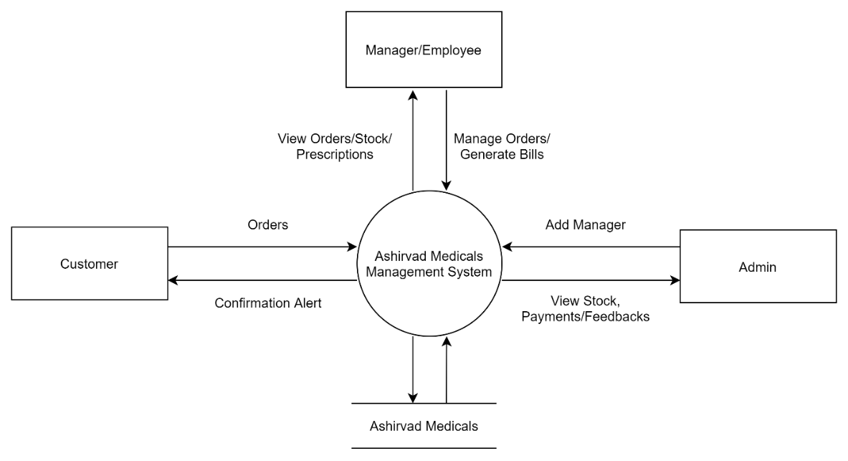

**Data Flow Diagram**

A data flow diagram is a graphical representation of the flow of data through an information system. A data flow diagram can also be used for the visualization of data processing. It is a common practice for a designer to draw a context level DFD. It shows the interaction between the system and the outside entities. This context level DFD is then exploded to show more detail of the system being modelled. A DFD shows the movement of data through the different transformations or processes in the system.

**Notations in the DFD**

|  |  |
| --- | --- |
| **Symbol** | **Description** |
|  | The circle represents a process. A process is named and each process is represented by a named circle. |
|  | The source or the sink is represented as a rectangular box. It represents the net originator or the consumer of the data that flows in the system. |
|  | The arrow represents the flow of data through the system. The labelled arrows enter or leave the bubbles. |
|  | The database is represented with the open box symbol. |

**Admin Level DFD (Level 1)**

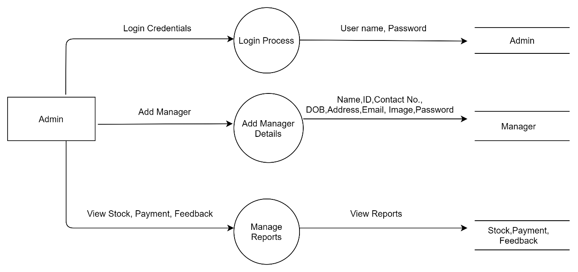

**Manager Level DFD (Level 1)**

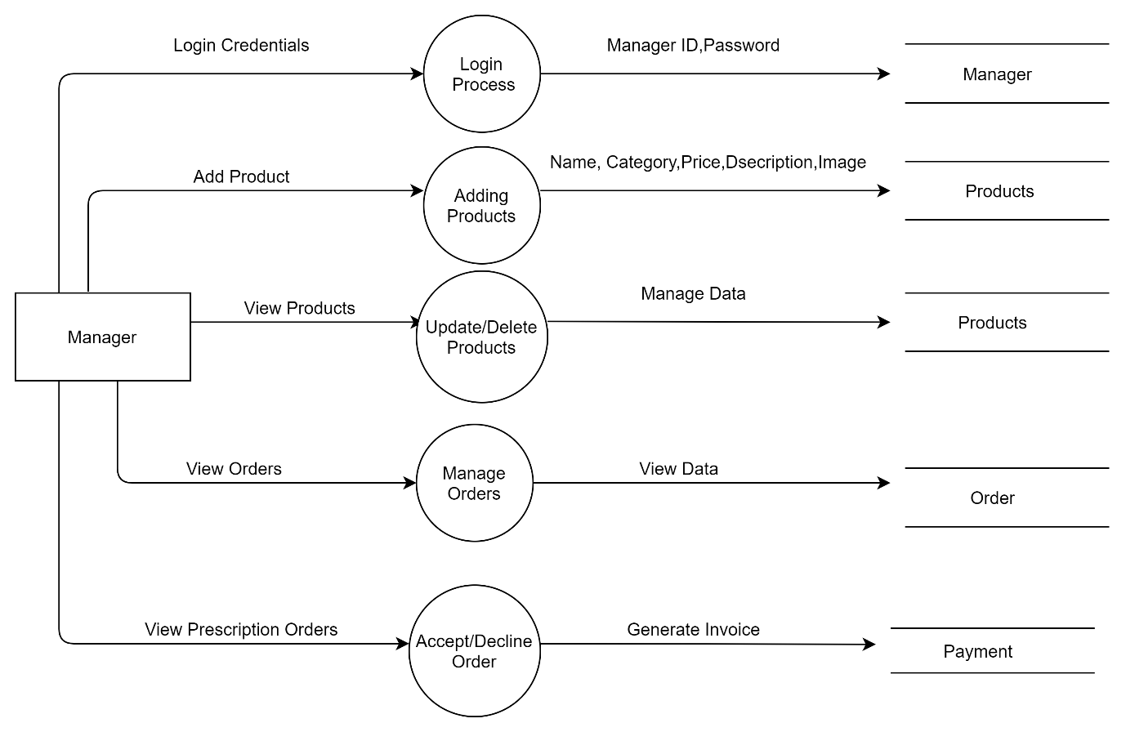

**Manager Level DFD (Level 2)**

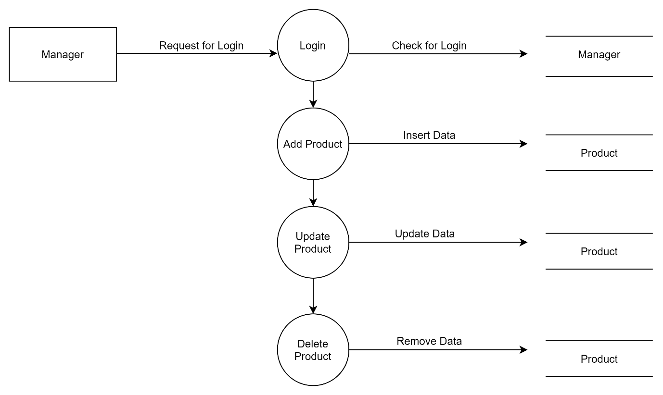

**Customer Level DFD (Leve1 1)**

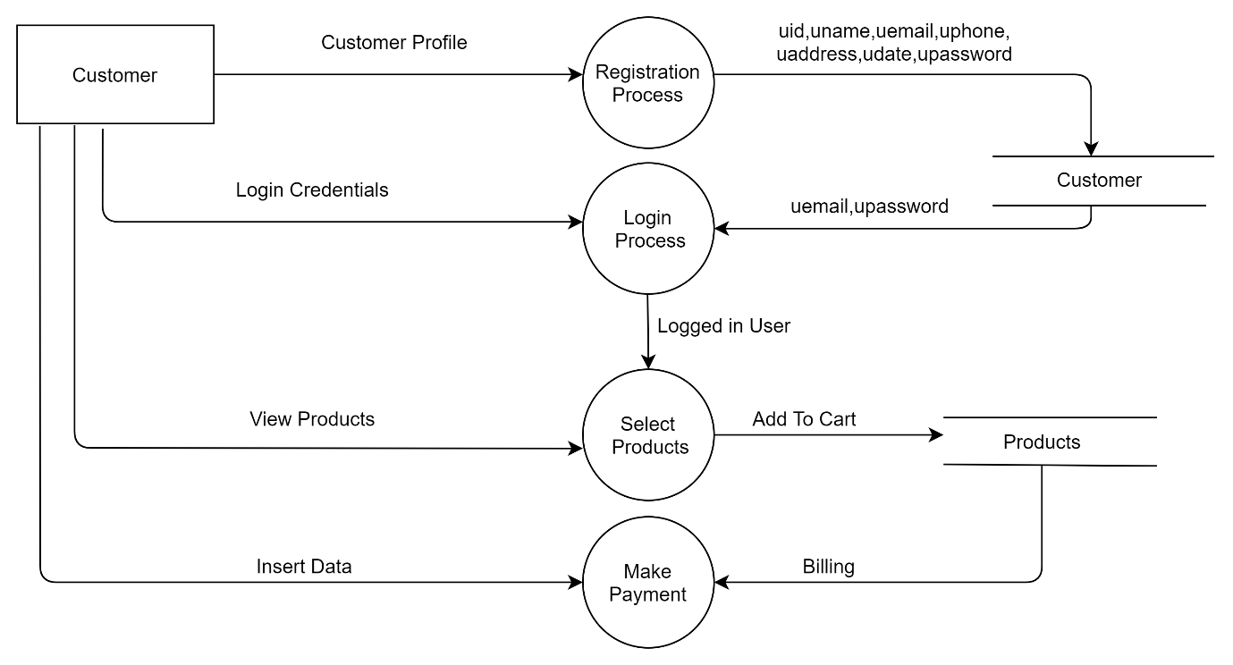

**Customer: level 2 DFD**

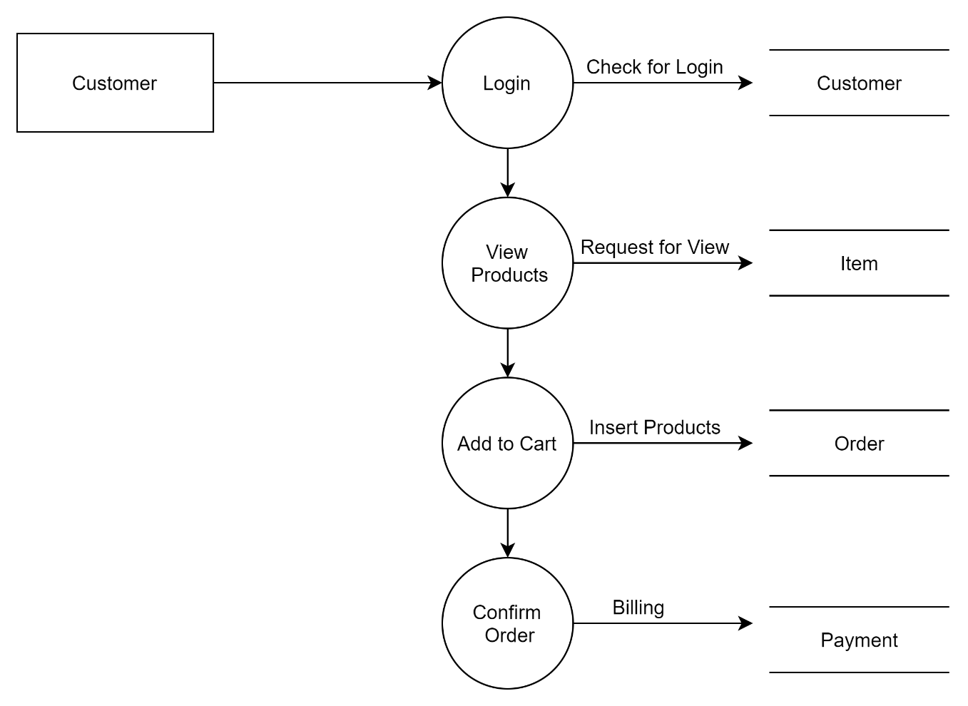

**DATABASE**

**DESIGN**

**DATABASE DESIGN**

**Introduction**

**Database:** A database is a collection of related data, which can be of any size and complexity. By using the concept of a database, we can easily store and retrieve data.

**Database Design:** The database design is done before building it to meet the needs of end users within a given information system that the database is intended to support. The database design defines the needed data and data structures that the database comprises. The database is physically implemented using Microsoft SQL Server Management Studio.

The database Ashirvad Medi Store is organized into 9 tables:

* admin
* feedback
* manager
* order
* payment
* product
* request
* stock
* user

Each entity can be described as follows along with its attributes.

**Table Name: admin**

|  |  |  |  |
| --- | --- | --- | --- |
| ***Column*** | ***Type*** | ***Index*** | ***Description*** |
| aid | int(11) | primary key | Admin Id |
| username | varchar(20) |  | Admin Name |
| password | varchar(20) |  | Admin Password |

**Table Name: feedback**

|  |  |  |  |
| --- | --- | --- | --- |
| ***Column*** | ***Type*** | ***Index*** | ***Description*** |
| fid | int(11) | primary key | Feedback Id |
| user_id | int(11) | yes | User Id |
| feedback | varchar(50) | yes | Feedback |
| uname | varchar(100) | yes | User Name |
| fdate | varchar(100) | yes | Feedback sent date |

**Table Name: manager**

|  |  |  |  |
| --- | --- | --- | --- |
| ***Column*** | ***Type*** | ***Index*** | ***Description*** |
| mid | int(11) |  | Serial.No |
| name | varchar(20) |  | Manager Name |
| email | varchar(200) |  | Manager Email |
| phone | bigint(10) |  | Contact Number |
| dob | date |  | Date of Birth |
| address | varchar(50) |  | Address |
| maid | varchar(11) |  | Manager Id |
| image | varchar(250) |  | Manager Image |
| date | date |  | Joined Date |
| password | varchar(20) |  | Password |

**Table Name: order**

|  |  |  |  |
| --- | --- | --- | --- |
| ***Column*** | ***Type*** | ***Index*** | ***Description*** |
| orid | int(11) |  | Order Id |
| usid | int(11) |  | User Id |
| prid | int(11) |  | Product Id |
| qty | int(11) |  | Quantity |
| cost | int(11) |  | Cost |
| total | int(11) |  | Total |
| odate | date |  | Ordered Date |
| ostatus | varchar(100) |  | Order Status |

**Table Name: payment**

|  |  |  |  |
| --- | --- | --- | --- |
| ***Column*** | ***Type*** | ***Index*** | ***Description*** |
| paid | Int(11) |  | Payment Id |
| usrid | Int(11) |  | User Id |
| amount | Int(11) |  | Amount |
| padate | Date |  | Payment Date |
| pastatus | Varchar(30) |  | Payment Status |
| tid | Int(100) |  | Transaction Id |
| ship | Varchar(1000) |  | Shipping Address |

**Table Name: product**

|  |  |  |  |
| --- | --- | --- | --- |
| ***Column*** | ***Type*** | ***Index*** | ***Description*** |
| pid | Int(11) |  | Product Id |
| pname | Varchar(25) |  | Product Name |
| description | Varchar(300) |  | Product Description |
| cost | Varchar(10) |  | Product Price |
| qty | Int(11) |  | Quantity |
| expdate | date |  | Expiry Date |
| pimage | Varchar(250) |  | Product Image |
| pdate | date |  | Added Date |
| ma_id | Int(11) |  | Manager Id |
| stock | Int(11) |  | Stock |
| catg | Varchar(100) |  | Category |

**Table Name: request**

|  |  |  |  |
| --- | --- | --- | --- |
| ***Column*** | ***Type*** | ***Index*** | ***Description*** |
| rid | Int(11) |  | Request Id |
| u_id | Int(11) |  | User Id |
| presimage | Varchar(250) |  | Prescription Image |
| rdate | Date |  | Requested Date |
| uname | Varchar(100) |  | User Name |
| uemail | Varchar(100) |  | User Email |
| rstatus | Varchar(50) |  | Request Status |

**Table Name: user**

|  |  |  |  |
| --- | --- | --- | --- |
| ***Column*** | ***Type*** | ***Index*** | ***Description*** |
| uid | Int(11) |  | User Id |
| uname | Varchar(20) |  | User Name |
| uemail | Varchar(25) |  | User Email |
| uphone | Bigint(10) |  | Contact Number |
| uaddress | Varchar(150) |  | User Address |
| udate | Date |  | Registered Date |
| upassword | Varchar(30) |  | User Passwords |

**Entity-Relationship (ER) Diagram**

An entity-relationship diagram is a specialized graphic that illustrates the relationships between entities in a database. ER diagrams often use symbols to represent three different types of information. Boxes are commonly used to represent entities. Diamonds are normally used to represent relationships and ovals are used to represent attributes.

The symbols are given below:

|  |  |  |
| --- | --- | --- |
| Name | Notation | Description |
| Entity |  | An entity is represented by a box within the diagram. Entities are equivalent to database tables. In a relational database, each row of the table represents an instance of that entity. |
| Relationship |  | Relationships are represented by diamonds. A relationship is a named collection or association between entities or used to relate to two or more entities with some common attributes or meaningful interaction between the objects. |
| Attributes |  | Attributes are represented by  ovals. An attribute is a single  data item related to a database  object. The database schema  associates one or more attributes  with each database entity |

ER- DIAGRAM

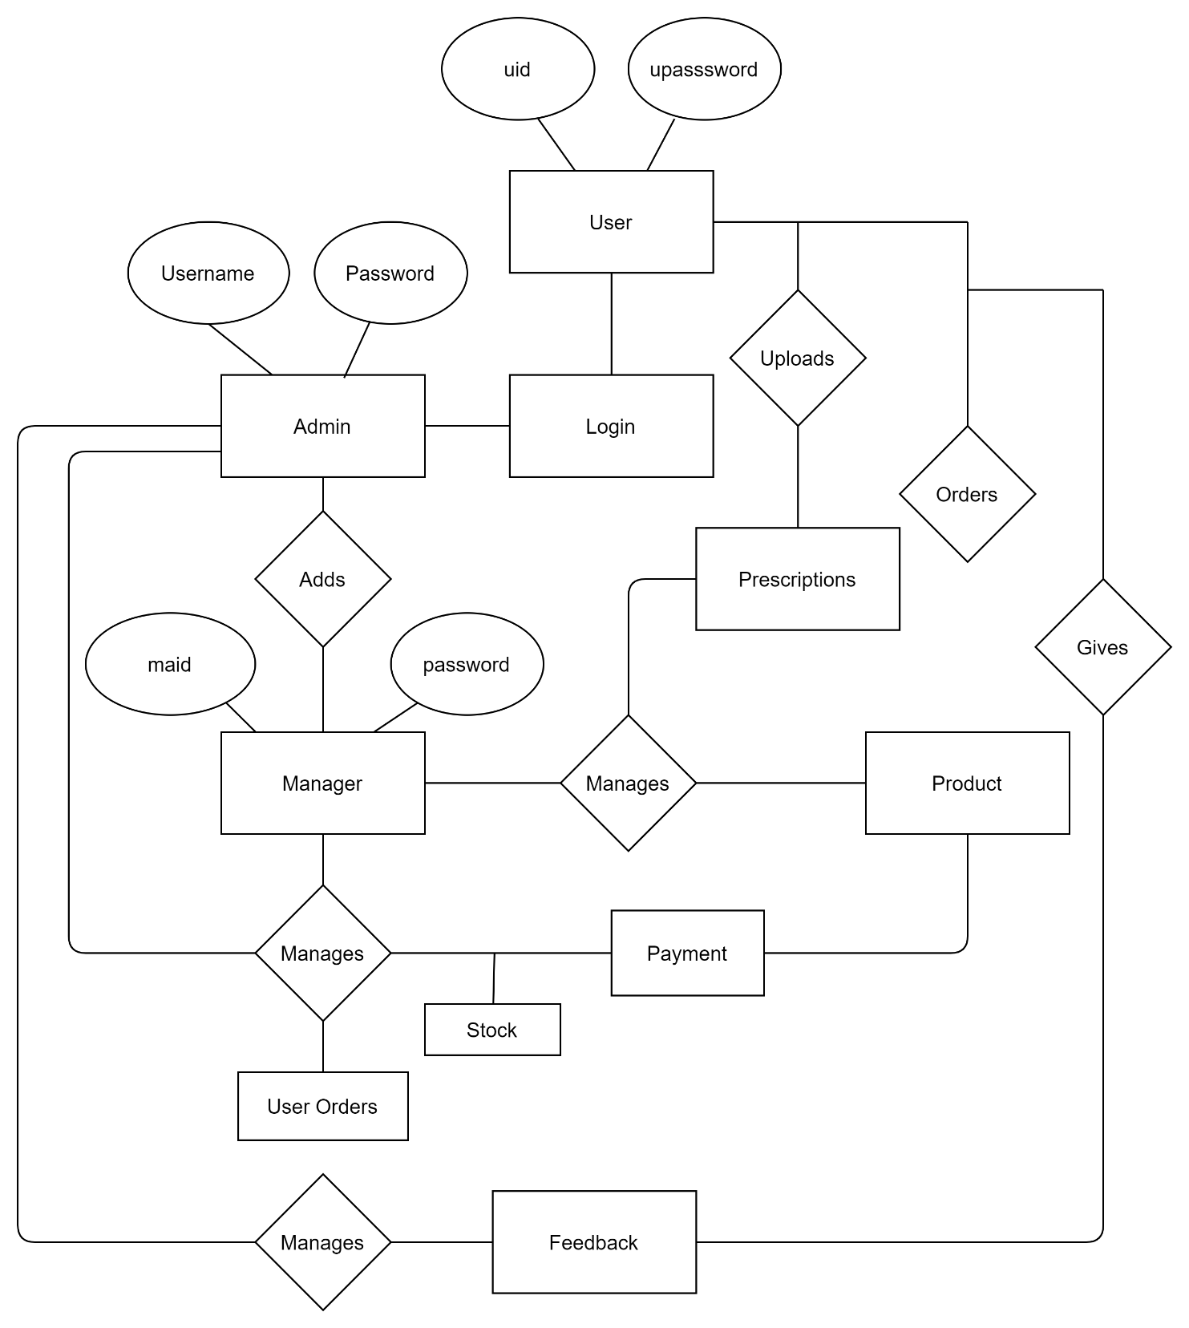

**DETAILED**

**DESIGN**

**DETAILED DESIGN**

**Introduction**

The purpose of preparing this document is to explain the complete design details of our Online Ashirvad Medi Store.

This detailed design report contains the general definition and features of the project, design constraints, the overall system architecture and data architecture. Additionally, a brief explanation about our current progress and schedule of the project will be provided in related sections. Design of the system and subsystems/modules will be explained both verbally and visually by means of diagrams in order to help the programmer to understand all the information stated in this document correctly and easily.

**Applicable Documents**

The documents used during detailed design are:

• System Requirements Document

• System Design

• Database Design

**Structure of the Software Package**

The components are:

* **Admin module**

The admin adds, edit and can view the manager details of the store and has the ability view orders, payments, stock and feedback. They can also delete products. They have ability to check the expiry date and to do the necessary.

* **Manager module**

The manager side interface is where the products are added, deleted, updated and viewed. The manager can view order, payment, stock, prescriptions and prescription bills. Prescription stock has a separate heading where the manager has to manually enter the stock.

* **Customer module**

The user can create an account and view all the products based on categories and view its description and prices and then add it to their cart and proceed with the payment. They are even able to add the doctor’s prescription. They can even edit their personal information.

**Modular Decomposition of the Components**

**1.1Admin Module**

**1.1.1Identification of the Modules**

The modules identified in this component are:

* Add Manager
* View Manager
* Edit Manager
* View Order
* View Payment
* View Stock
* View Feedback

**1.1.2. Structure Chart for the Admin Module**

ADMIN

VIEW PAYMENT

VIEW ORDER

EDIT MANAGER

VIEW MANAGER

ADD

MANAGER

VIEW FEEDBACK

VIEW STOCK

**1.2. Manager Module**

**1.2.1. Identification of the Modules**

The modules identified in this component are:

* Add Product
* View Product
* Edit Product
* Delete Product
* View Order
* View Payment
* View Stock
* View Prescription
* Edit Prescription Stock

**1.2.2. Structure Chart for the Manager Module**

EDIT PRESCRIPTION STOCK

ADD PRODUCT

MANAGERANAGER

VIEW PRESCRIPTION

VIEW STOCK

VIEW PAYMENT

VIEW ORDER

DELETE PRODUCT

EDIT PRODUCT

VIEW PRODUCT

**1.3. Customer Module**

**1.3.1. Identification of the Modules**

The modules identified in this component are:

* Register
* Edit Profile
* View Products
* Add to Cart
* Make Payment
* Upload Prescription
* Give Feedback

**1.3.2. Structure Chart for the Dashboard Module**

CUSTOMER

GIVE FEEDBACK

REGISTER

UPLOAD PRESCRIPTION

MAKE PAYMENT

ADD TO CART

VIEW PRODUCTS

EDIT PROFILE

**TESTING**

**TESTING OVERVIEW**

1. **Introduction**

Software testing is an investigation conducted to provide stack holders with information about the quality of the product or service under test. Testing has been defined as the process of analysing a software item to detect the differences between the existing and required conditions and to evaluate the features of the software item. It involves operation of a system or application under controlled conditions and evaluating the results. The controlled conditions should include both normal and abnormal conditions.

1. **Testing Objectives** 
   * Finding defects which are created by the programmer while developing the software.
   * To prevent defects.
   * To make sure that the end results meet the business and user requirements.
   * To ensure that it satisfies the BRS (Business Requirements Specification) and SRS (System Requirements Specification).
2. **Testing Methods**

System testing is the stage of implementation. This is to check whether the system works accurately and efficiently before live operation commences. Testing is vital to the success of the system.

**4. Steps for Testing**

**4.1. Unit Testing**

Unit Testing focuses efforts on the smallest unit of software design. This is known as Module Testing. The modules are tested separately. The test is carried out during the programming stage itself. In this step, each module is found to be working satisfactorily with regard to the expected output from the module.

**4.2. Integration Testing**

Integration testing is a systematic approach for constructing the program structure, while at the same time conducting tests to uncover errors associated within the interface. The objective is to take unit tested modules and build program structures. All the modules are combined and tested as a whole.

**4.3. Validation Testing**

In validation testing we ensure that all the data entered is displayed properly on the view screen and that we got the expected results.

**4.4. Output Testing**

After performing Validation Testing, the next step is Output Testing of the proposed system. No system can be useful if it does not produce the required output in a specific format. If the output format on the screen is found to be correct, then output testing did not result in any correction for the system.

1. **Test cases**
2. **USER REGISTRATION FORM:**

|  |  |  |  |  |
| --- | --- | --- | --- | --- |
| **S.NO** | **CONDITIONS** | **TEST DATA** | **EXPECTED OUTPUT** | **REMARKS** |
| 1. | If the name is empty. | First Name | Please fill in this field. | Successful |
| 2. | If email is empty. | Email ID | Please fill in this field. | Successful |
| 3. | If email is not of required format. | Email ID | Invalid Email ID. | Successful |
| 4. | If contact number is empty. | Contact Number | Please fill in this field. | Successful |
| 5. | If address is empty. | Address | Please fill in this field. | Successful |
| 6. | If password is empty. | Password | Please fill in this field. | Successful |
| 7. | If the password entered has no special characters, numbers, uppercase and is less than 8 characters. | Password | Password should be at least 8 characters in length and should include at least one upper case letter, one number, and one special. | Successful |
| 8. | If confirm password is empty. | Confirm Password | Please fill in this field. | Successful |
| 9. | If password and confirm password doesn’t match. | Confirm Password | Both passwords should match. | Successful |

**USER LOGIN FORM:**

|  |  |  |  |  |
| --- | --- | --- | --- | --- |
| **S.NO** | **CONDITIONS** | **TEST DATA** | **EXPECTED OUTPUT** | **REMARKS** |
| 1. | If email is empty. | Email ID | Please fill in this field. | Successful |
| 2. | If email is not of required format. | Email ID | Invalid Email ID. | Successful |
| 3. | If the email is not registered. | Email ID | You have entered the wrong email or password. | Successful |
| 4. | If the password is empty. | Password | Please fill in this field. | Successful |
| 5. | If password is incorrect. | Password | You have entered the wrong email or password. | Successful |

**EDIT USER REGISTER FORM:**

|  |  |  |  |  |
| --- | --- | --- | --- | --- |
| **S.NO** | **CONDITIONS** | **TEST DATA** | **EXPECTED OUTPUT** | **REMARKS** |
| 1. | If the name is empty. | First Name | Please fill in this field. | Successful |
| 2. | If email is empty. | Email ID | Please fill in this field. | Successful |
| 3. | If email is not of required format. | Email ID | Invalid Email ID. | Successful |
| 4. | If contact number is empty. | Contact Number | Please fill in this field. | Successful |
| 5. | If address is empty. | Address | Please fill in this field. | Successful |
| 6. | If old password is empty. | Old Password | Please fill in this field. | Successful |
| 7. | If the old password doesn’t match the existing password. | Old Password | Old password should match the existing password. | Successful |
| 8. | If new password is empty. | New Password | Please fill in this field. | Successful |
| 9. | If new password entered has no special characters, numbers, uppercase and is less than 8 characters. | New Password | Password should be at least 8 characters in length and should include at least one upper case letter, one number, and one special. | Successful |
| 10. | If confirm password is empty. | Confirm Password | Please fill in this field. | Successful |
| 11. | If new password and confirm password doesn’t match. | Confirm Password | Both passwords should match. | Successful |

**FEEDBACK FORM:**

|  |  |  |  |  |
| --- | --- | --- | --- | --- |
| **S.NO** | **CONDITIONS** | **TEST DATA** | **EXPECTED OUTPUT** | **REMARKS** |
| 1. | If name is empty. | Full Name | Please fill in this field. | Successful |
| 2. | If message is empty. | Message | Please fill in this field. | Successful |

**UPLOAD PRESCRIPTION:**

|  |  |  |  |  |
| --- | --- | --- | --- | --- |
| **S.NO** | **CONDITIONS** | **TEST DATA** | **EXPECTED OUTPUT** | **REMARKS** |
| 1. | If not chosen a file. | Choose File | Please select a file. | Successful |
| 2. | If the file chosen is not of the required format. | Choose File | PLEASE ADD AN IMAGE(".png", ".jpeg" or ".jpg"). | Successful |

**PAYMENT:**

|  |  |  |  |  |
| --- | --- | --- | --- | --- |
| **S.NO** | **CONDITIONS** | **TEST DATA** | **EXPECTED OUTPUT** | **REMARKS** |
|  |  |  |  |  |
|  |  |  |  |  |
|  |  |  |  |  |
|  |  |  |  |  |
|  |  |  |  |  |

**ADMIN LOGIN FORM:**

|  |  |  |  |  |
| --- | --- | --- | --- | --- |
| **S.NO** | **CONDITIONS** | **TEST DATA** | **EXPECTED OUTPUT** | **REMARKS** |
| 1. | If name is empty. | Name | Please fill in this field. | Successful |
| 2. | If name is not registered. | Name | You have entered the wrong email or password. | Successful |
| 3. | If password is empty. | Password | Please fill in this field. | Successful |
| 4. | If password is incorrect. | Password | You have entered the wrong email or password. | Successful |

**CHANGE ADMIN FORM:**

|  |  |  |  |  |
| --- | --- | --- | --- | --- |
| **S.NO** | **CONDITIONS** | **TEST DATA** | **EXPECTED OUTPUT** | **REMARKS** |
| 1. | If old password is empty. | Old Password | Please fill in this field. | Successful |
| 2. | If old password doesn’t match existing password. | Old Password | Old password should match the existing password. | Successful |
| 3. | If new password is empty. | New Password | Please fill in this field. | Successful |
| 4. | If confirm password is empty. | Confirm Password | Please fill this field. | Successful |
| 5. | If new password and confirm password doesn’t match. | Confirm Password | Both passwords should match. | Successful |

**ADD MANAGER:**

|  |  |  |  |  |
| --- | --- | --- | --- | --- |
| **S.NO** | **CONDITIONS** | **TEST DATA** | **EXPECTED OUTPUT** | **REMARKS** |
| 1. | If name is empty. | Manager Name | Please fill in this field. | Successful |
| 2. | If ID is empty. | Manager ID | Please fill in this field. | Successful |
| 3. | If number is empty. | Contact Number | Please fill in this field. | Successful |
| 4. | If date of birth is empty. | Date of Birth | Please fill in this field. | Successful |
| 5. | If address is empty. | Address | Please fill in this field. | Successful |
| 6. | If picture is empty. | Photo of Manager | Please select a file. | Successful |
| 7. | If the file chosen is not of the required format. | Photo of Manager | PLEASE ADD AN IMAGE(".png", ".jpeg" or ".jpg"). | Successful |
| 8. | If password is empty. | Password | Please fill in this page. | Successful |

**EDIT MANAGER:**

|  |  |  |  |  |
| --- | --- | --- | --- | --- |
| **S.NO** | **CONDITIONS** | **TEST DATA** | **EXPECTED OUTPUT** | **REMARKS** |
| 1. | If name is empty. | Manager Name | Please fill in this field. | Successful |
| 2. | If ID is empty. | Manager ID | Please fill in this field. | Successful |
| 3. | If number is empty. | Contact Number | Please fill in this field. | Successful |
| 4. | If date of birth is empty. | Date of Birth | Please fill in this field. | Successful |
| 5. | If address is empty. | Address | Please fill in this field. | Successful |
| 6. | If picture is empty. | Photo of Manager | Please select a file. | Successful |
| 7. | If the file chosen is not of the required format. | Photo of Manager | PLEASE ADD AN IMAGE(".png", ".jpeg" or ".jpg"). | Successful |
| 8. | If password is empty. | Password | Please fill in this page. | Successful |

|  |  |  |  |  |
| --- | --- | --- | --- | --- |
| **S.NO** | **CONDITIONS** | **TEST DATA** | **EXPECTED OUTPUT** | **REMARKS** |
| 1. | If ID is empty. | Manager ID | Please fill in this field. | Successful |
| 2. | If ID is not registered. | Manager ID | You have entered the wrong ID or password. | Successful |
| 3. | If password is empty. | Password | Please fill in this field. | Successful |
| 4. | If password is incorrect. | Password | You have entered the wrong ID or password. | Successful |

**ADD PRODUCTS:**

|  |  |  |  |  |
| --- | --- | --- | --- | --- |
| **S.NO** | **CONDITIONS** | **TEST DATA** | **EXPECTED OUTPUT** | **REMARKS** |
| 1. | If product name is empty. | Product Name | Please fill in this field. | Successful |
| 2. | If category is not selected. | Category | Please select a category. | Successful |
| 3. | If price is not selected. | Price | Please fill in this field. | Successful |
| 4. | If quantity is not selected. | Quantity | Please fill in this field. | Successful |
| 5. | If stock is empty. | Stock | Please fill in this field. | Successful |
| 6. | If description is empty. | Description | Please fill in this field. | Successful |
| 7. | If image is not selected. | Product Image | Please select a file. | Successful |
| 8. | If the file chosen is not of the required format. | Product Image | PLEASE ADD AN IMAGE(".png", ".jpeg" or ".jpg"). | Successful |

**EDIT PRODUCTS:**

|  |  |  |  |  |
| --- | --- | --- | --- | --- |
| **S.NO** | **CONDITIONS** | **TEST DATA** | **EXPECTED OUTPUT** | **REMARKS** |
| 1. | If product name is empty. | Product Name | Please fill in this field. | Successful |
| 2. | If category is not selected. | Category | Please select a category. | Successful |
| 3. | If price is not selected. | Price | Please fill in this field. | Successful |
| 4. | If quantity is not selected. | Quantity | Please fill in this field. | Successful |
| 5. | If stock is empty. | Stock | Please fill in this field. | Successful |
| 6. | If description is empty. | Description | Please fill in this field. | Successful |
| 7. | If image is not selected. | Product Image | Please select a file. | Successful |
| 8. | If the file chosen is not of the required format. | Product Image | PLEASE ADD AN IMAGE(".png", ".jpeg" or ".jpg"). | Successful |

**USER**

**MANUAL**

**USER MANUAL**

The user manual gives a rough idea about the working of the system, so that any user can easily interact with the system. It includes the entire details starting from how one can login to the system; it tells what can be done after logging into the system.

Ashirvad Medi Store is a user friendly stand-alone application which is developed using JavaScript as front-end and PHP as the back-end. This software requires manual installation by the user. The user manual of Ashirvad Medi Store is as follows.

**Admin Login**

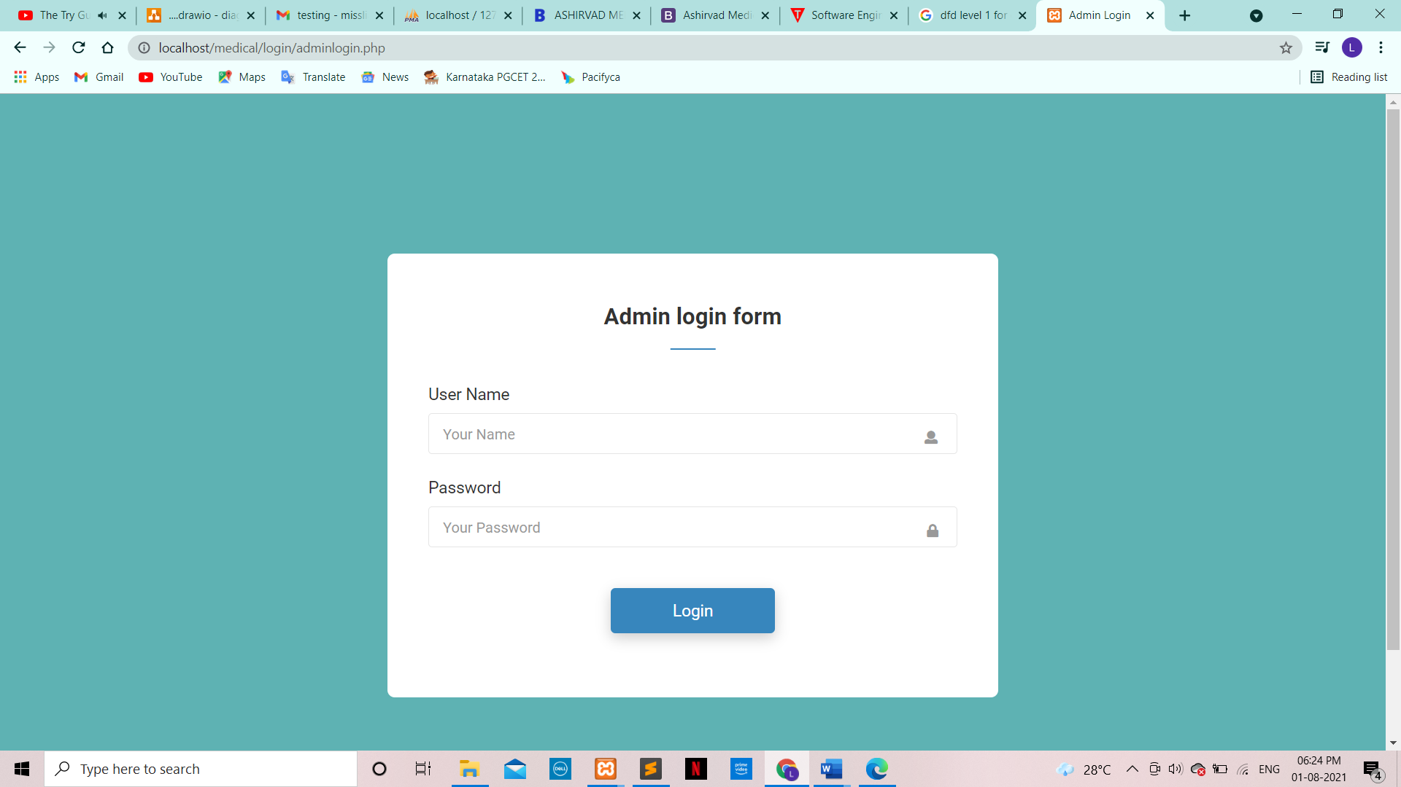

**USE:** This form enables an admin to log into the system.

**Add Manager Tab**

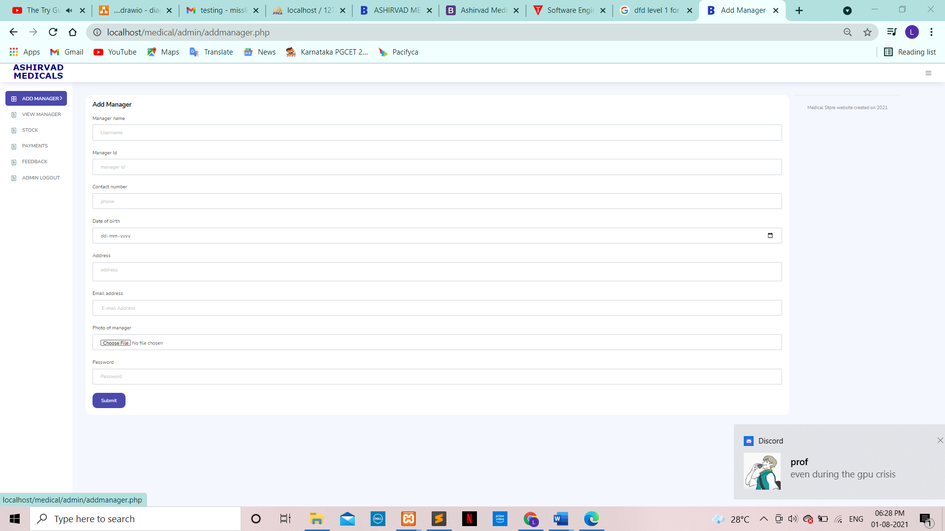

**USE:** The Add Manager tab allows the admin to add a manager

**View Manager Tab**

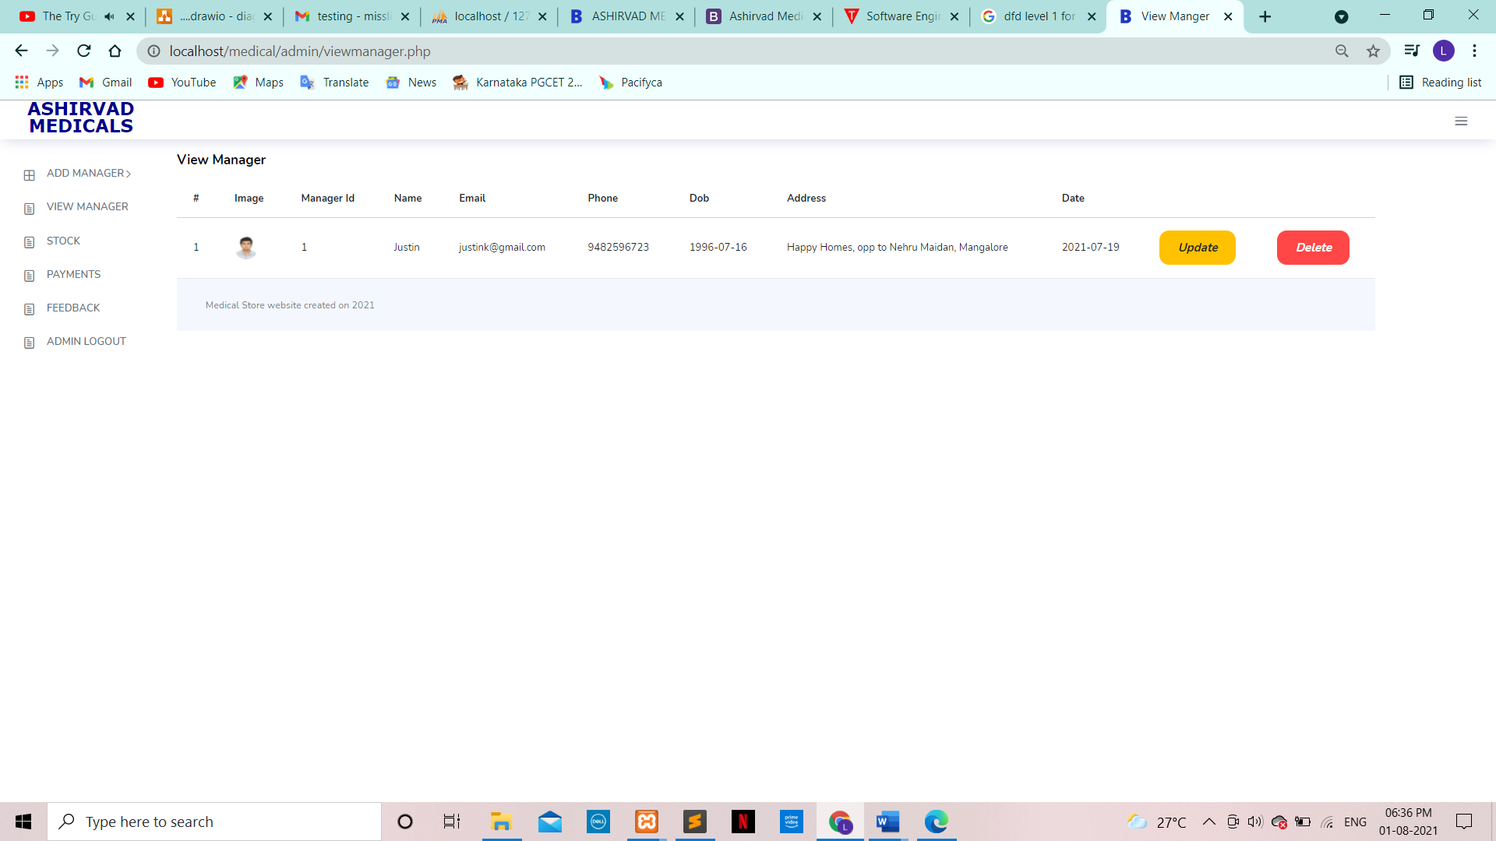

**USE:** The View Manager tab allows the admin to edit/delete manager details.

**View Stock Tab**

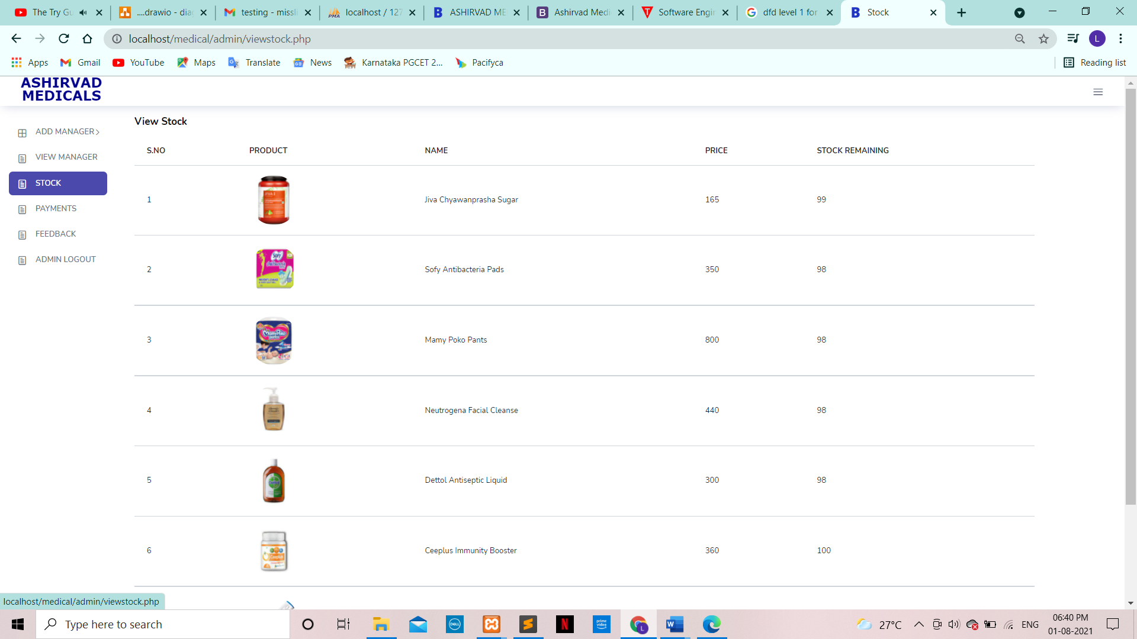

**USE:** This enables the admin to view the stock remaining along with the product, name and price.

**Payments Tab**

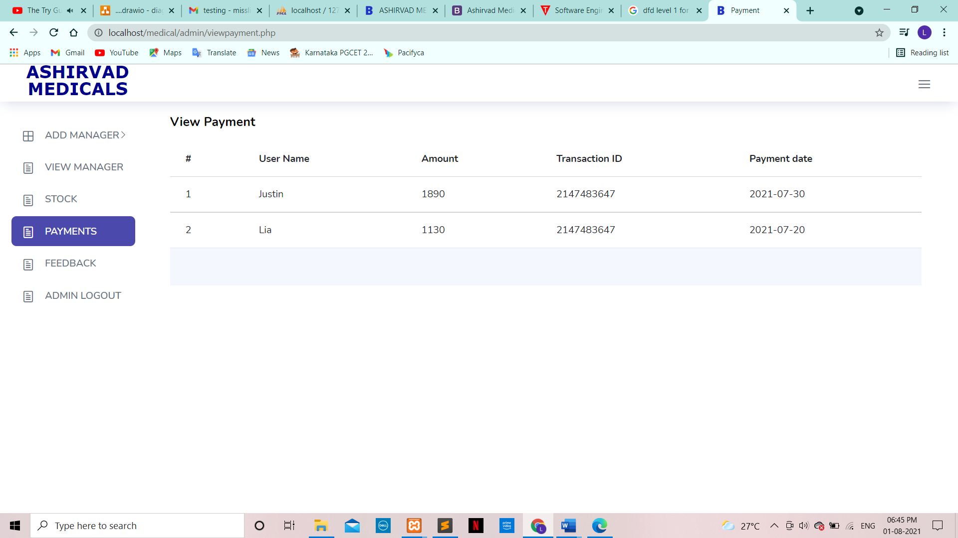

**USE:** This enables the admin to view the payments made by the customer.

**Feedback Tab**

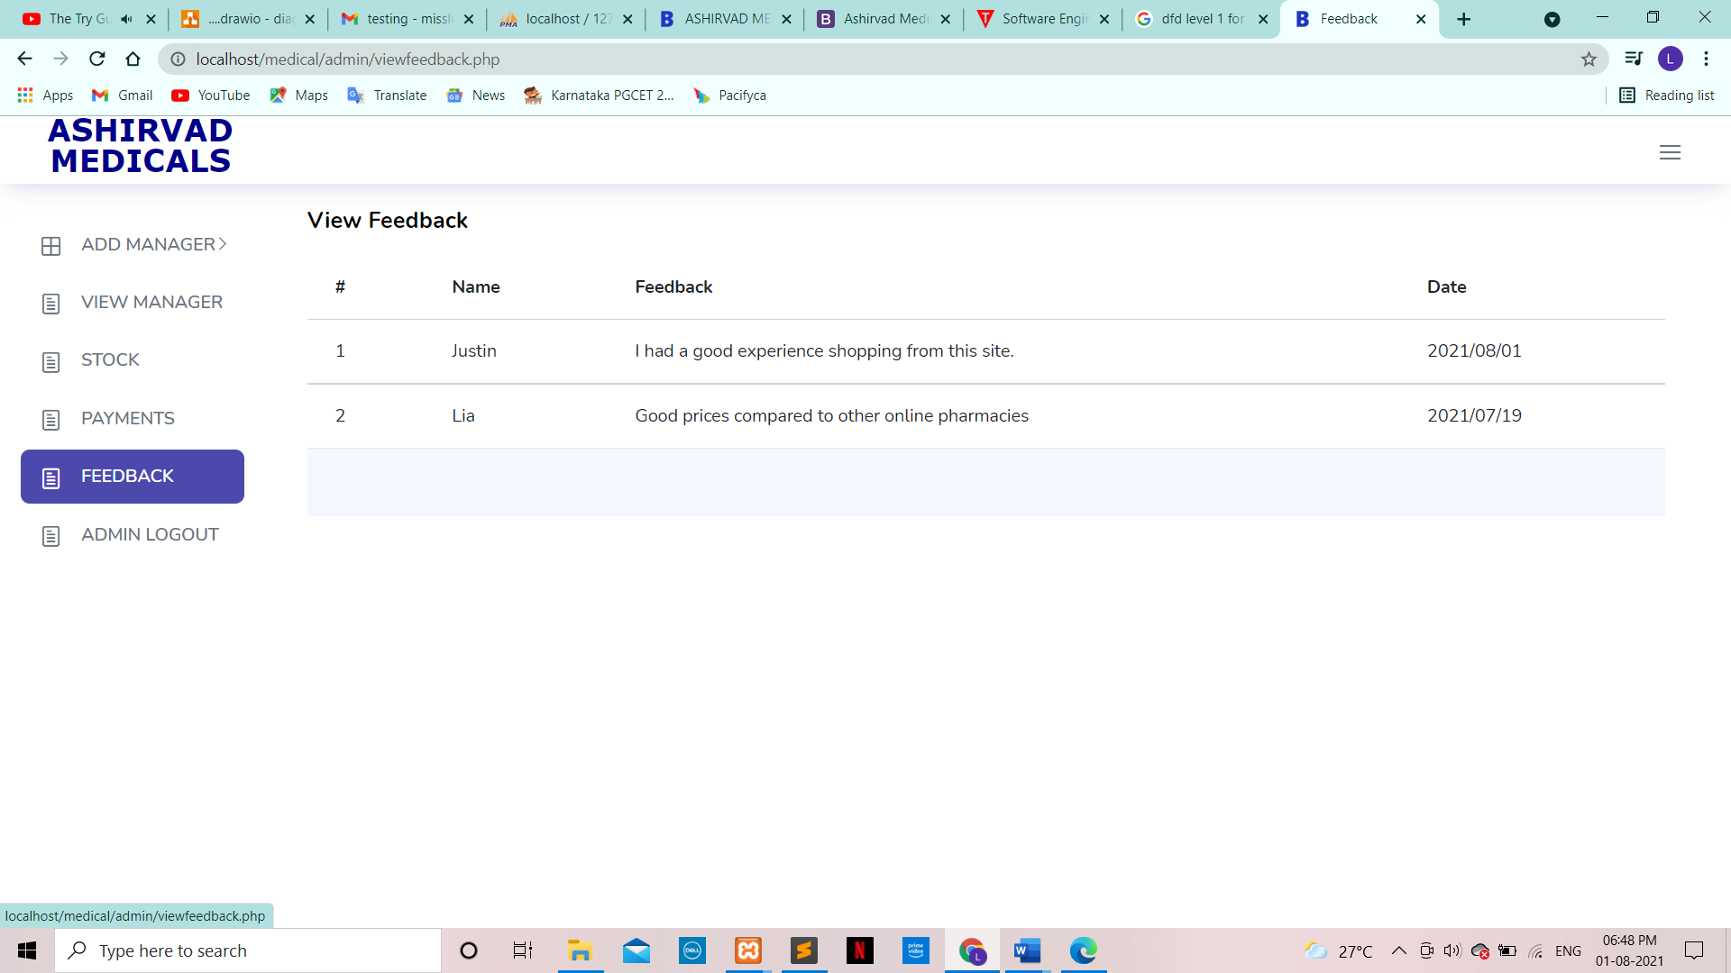

**USE:** This enables the admin to view the feedbacks made by the customer.

**Manager Login**

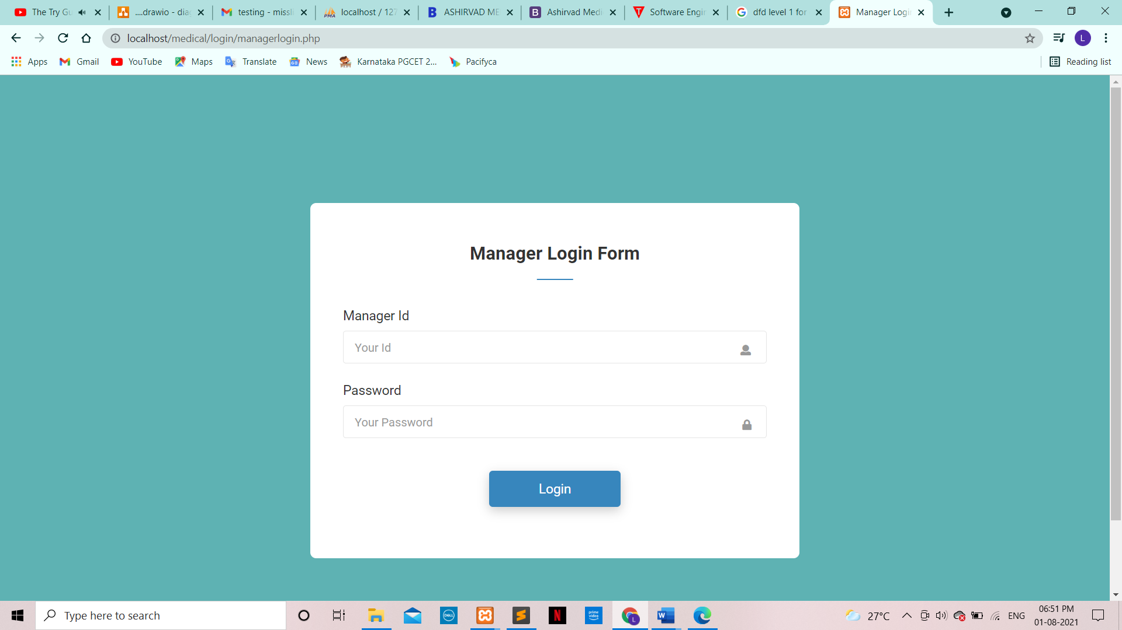

**USE:** This form enables an manager to log into the system.

**Medicine Tab**

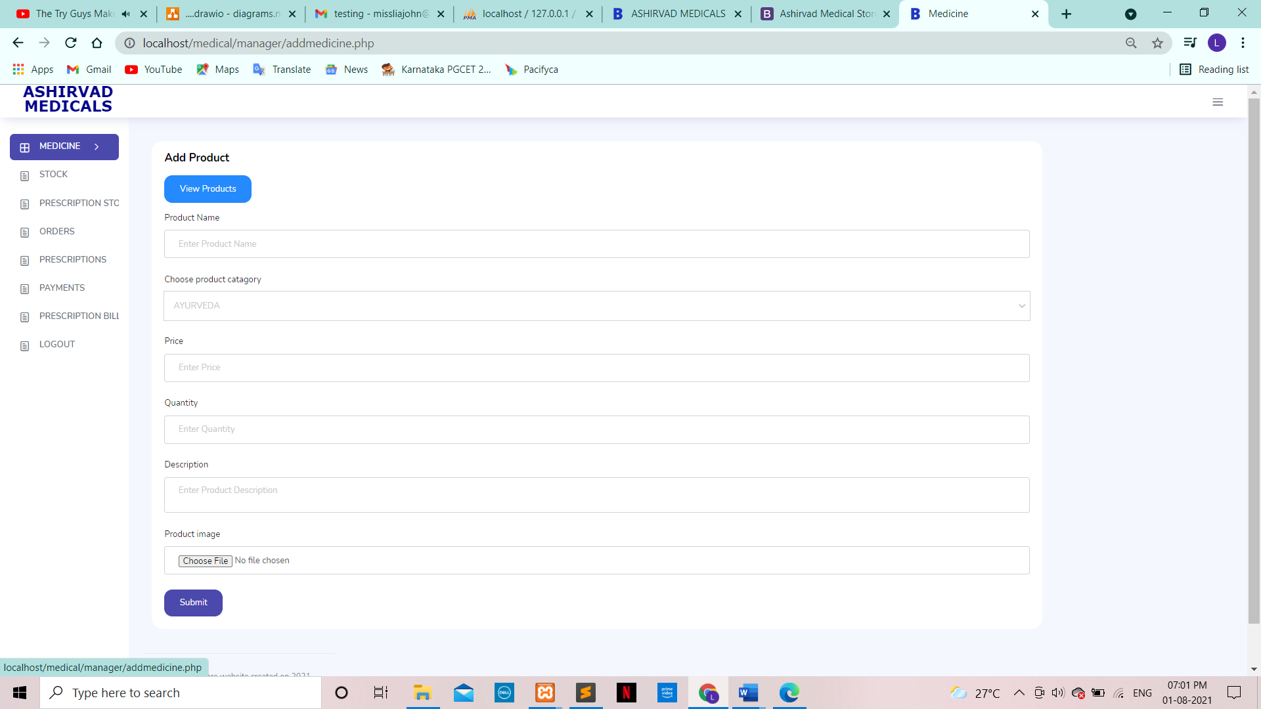

**USE:** This tab enables a manager to add products.

**View Products Tab**

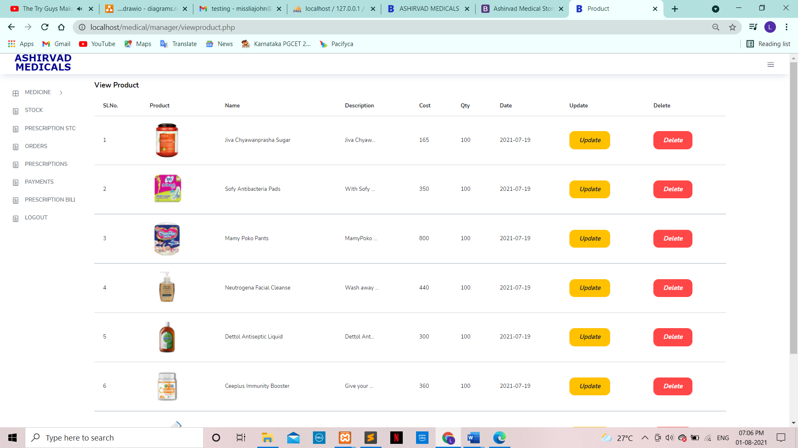

**USE:** This tab enables a manager view, update or delete products.

**Stock Tab**

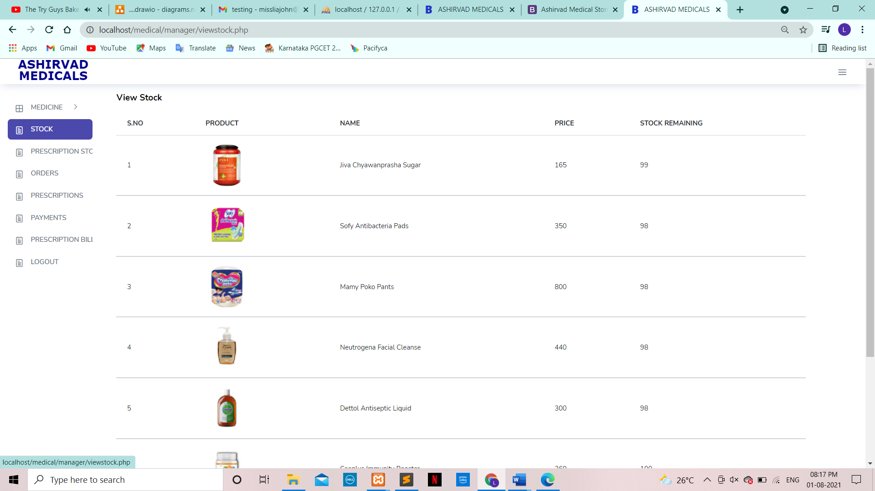

**USE:** This tab enables a manager to keep track of the stock.

**Prescription Stock Tab**

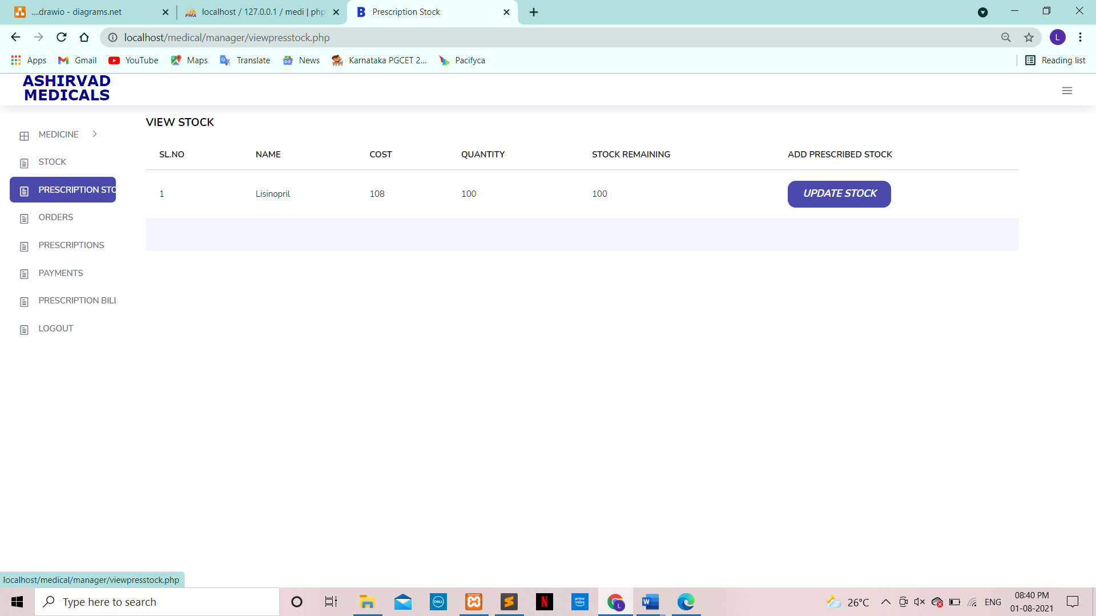

**USE:** This tab enables a manager to update the prescription medication’s stock manually.

**Orders Tab**

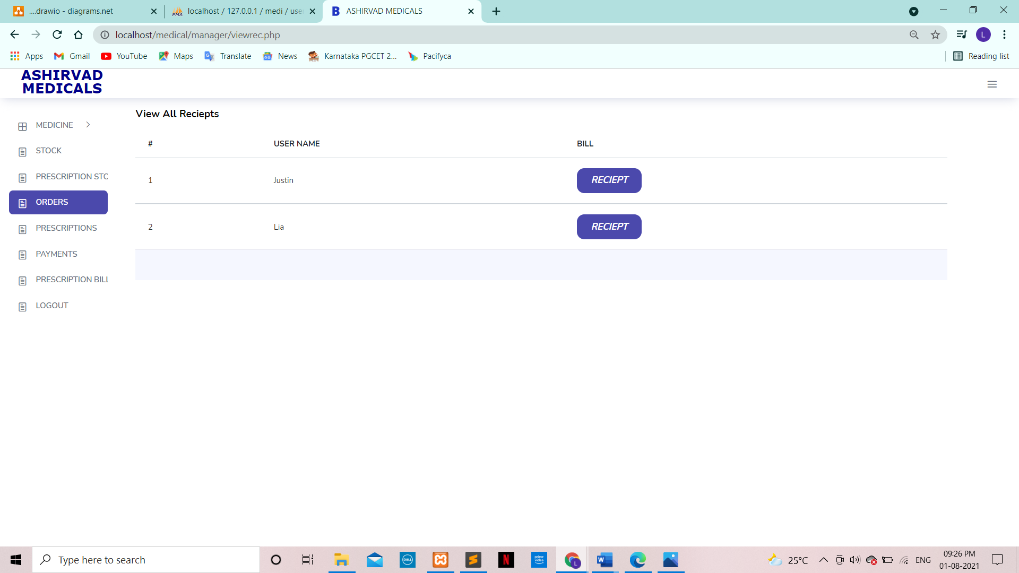

**USE:**

* This tab enables a manager to view customer’s orders.
* The Receipt button opens an individual customer’s order information.

**Receipt Tab**

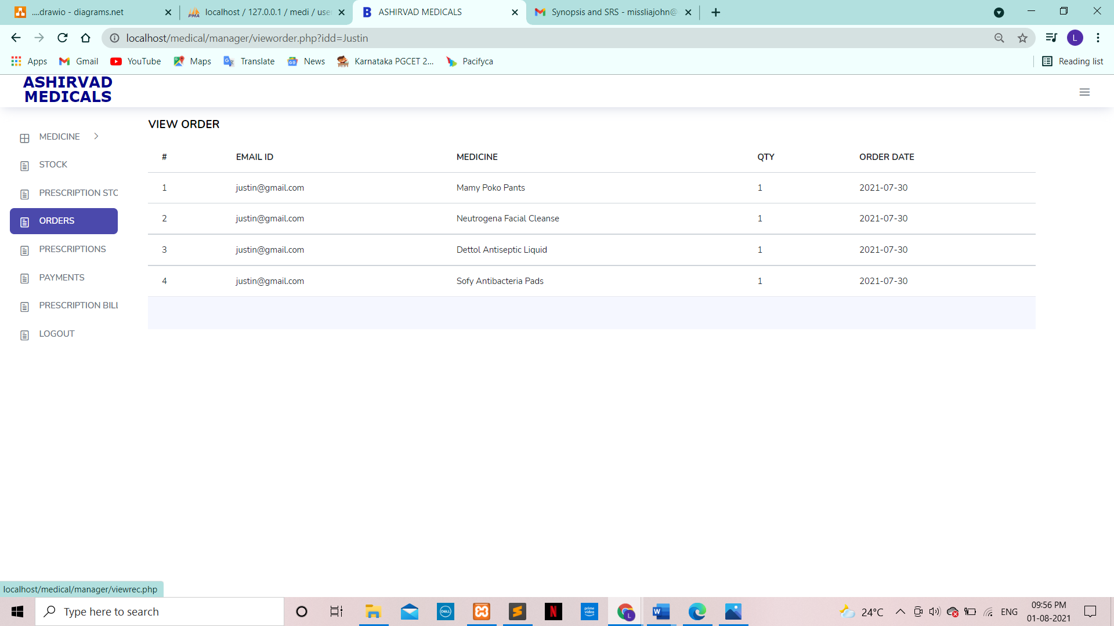

**USE:** This table shows the manager a customer’s list of products they have ordered.

**Prescription Tab**

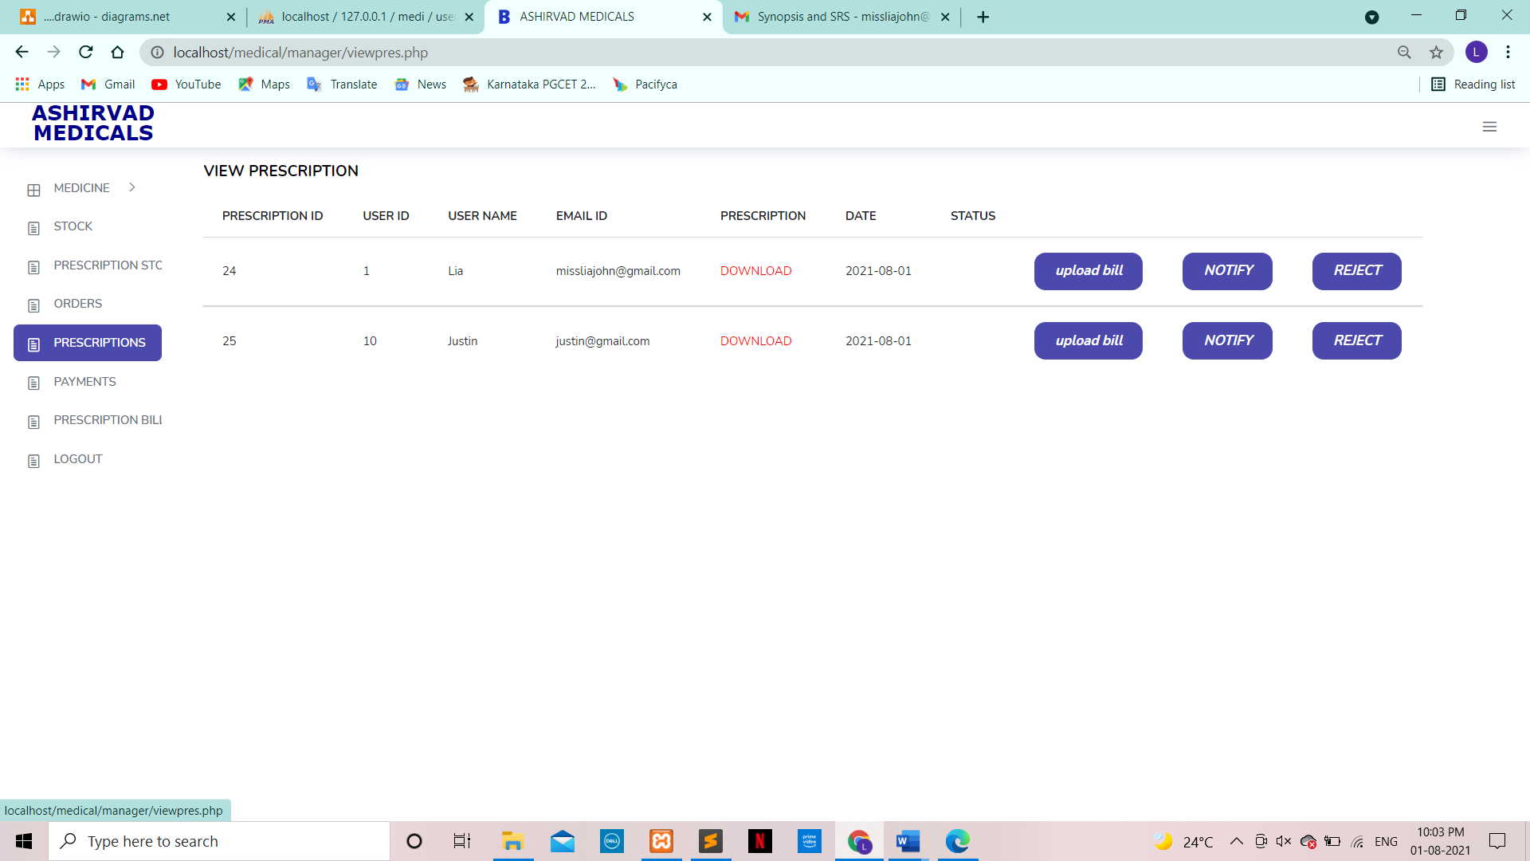

**USE:**

* This tab enables the manager to send a notification to the customer whether the prescription has been accepted or rejected.
* After sending a notification, the manager can then manually generate a prescription bill and upload it in the “upload bill”

**Payment Tab**

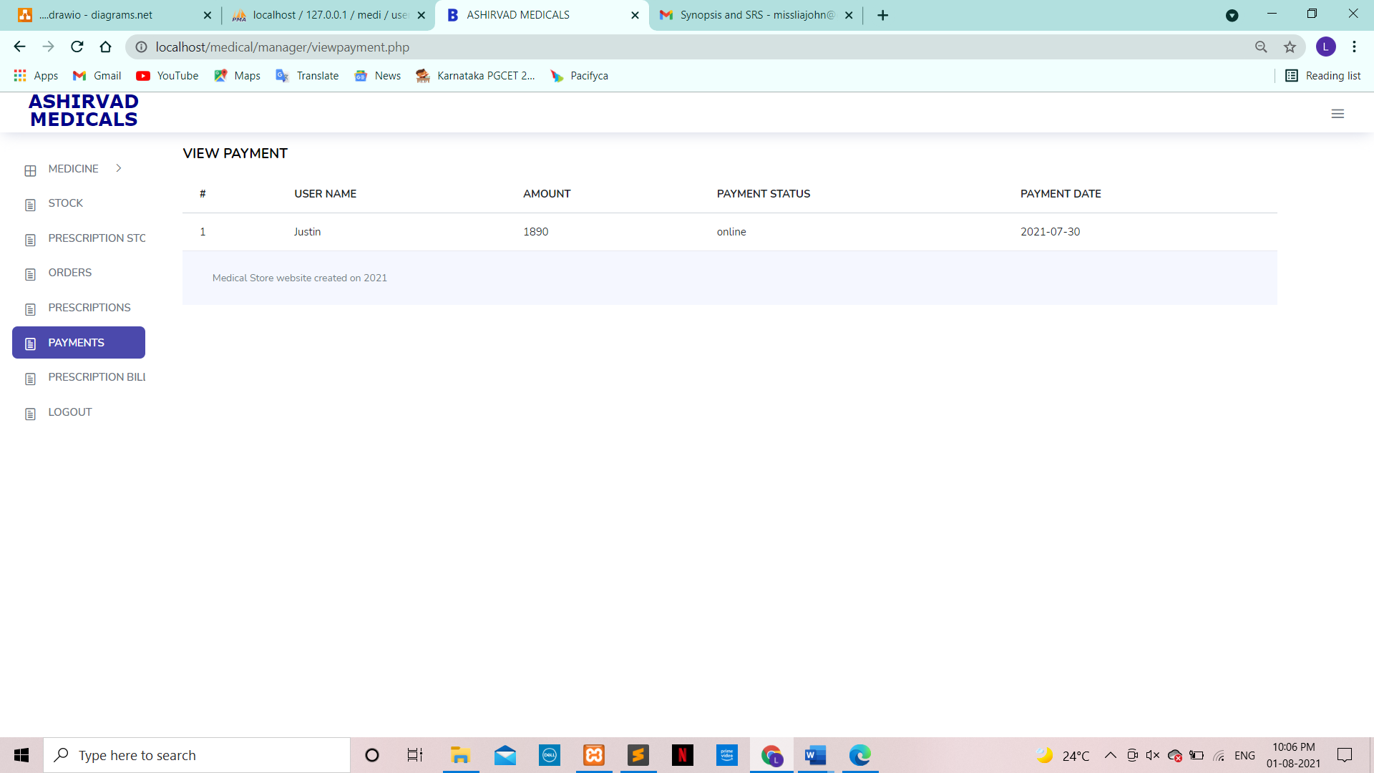

**USE:** This tab shows the manager the payments that have successfully come through.

**Prescription Tab**

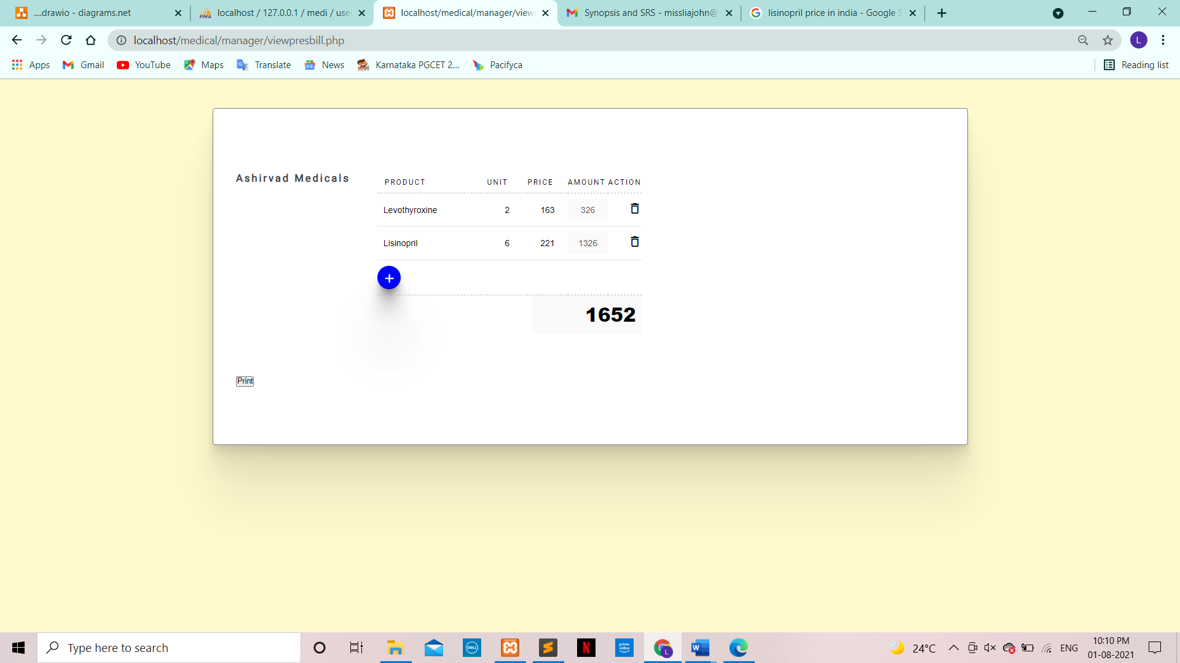

**USE:**

* This tab allows the manager to manually enter product names, quantity and price for the products sent on the prescription.

After generating the bill, it needs to be printed and uploaded in “upload bill” under “prescriptions”.

**Upload Bill Tab**

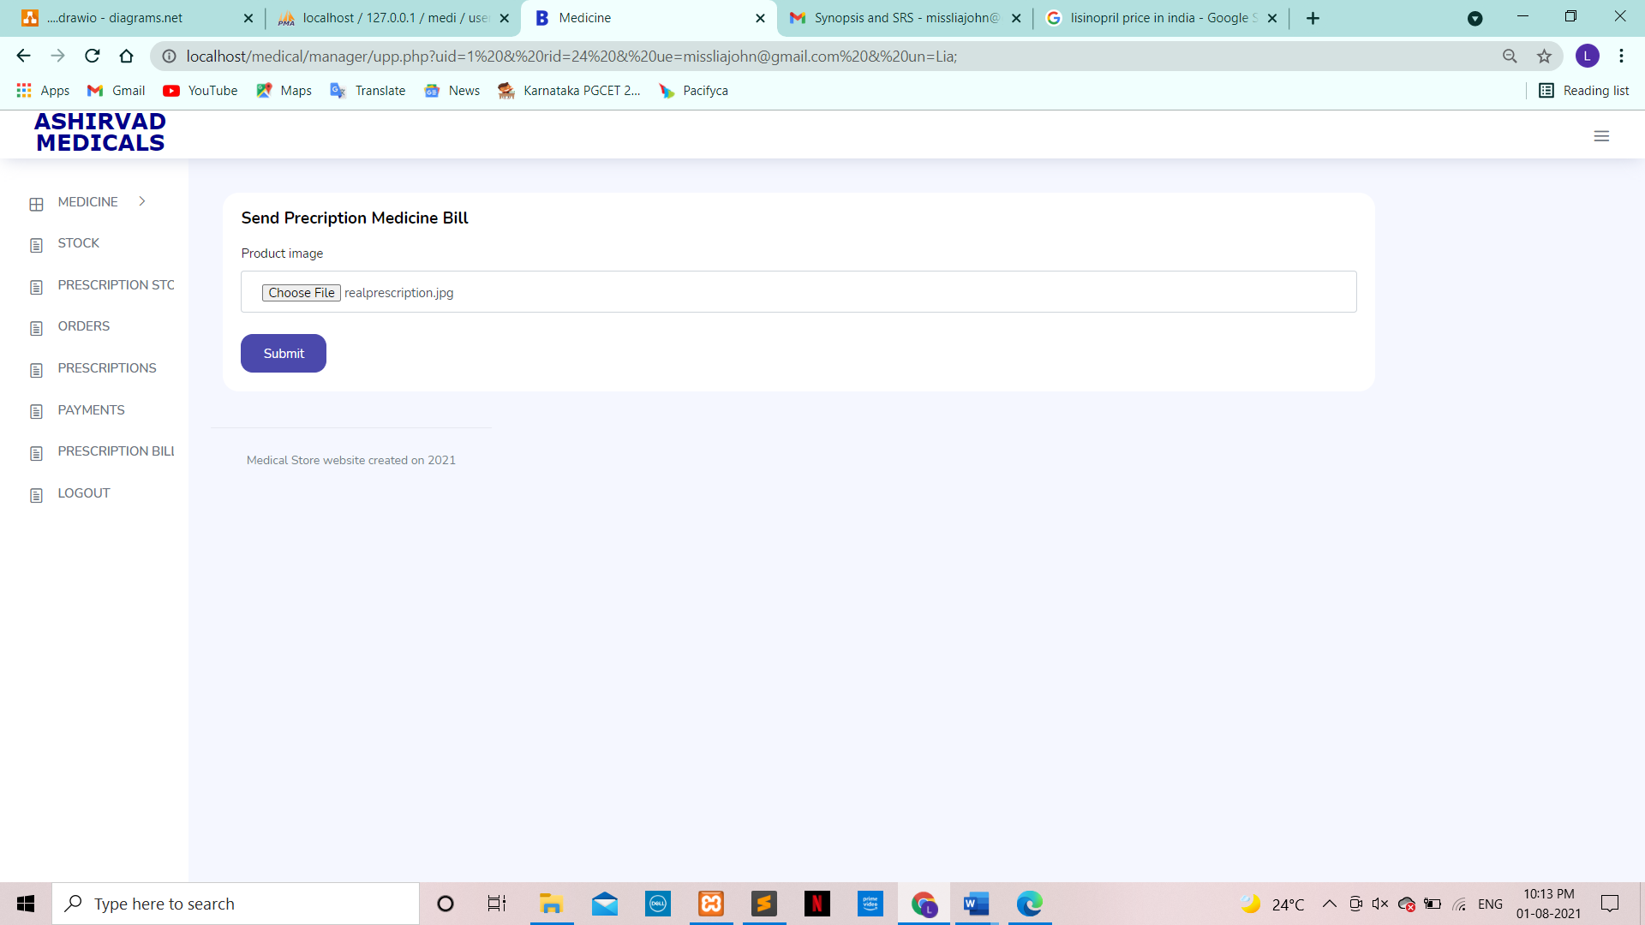

**USE:** This tab allows manager to upload the manually generated prescription bill and submit it to the user side for the customer to view.

**Introduction Tab**



**USE:** Login tab will enable the user to start the logging in process.

**Introduction Tab**

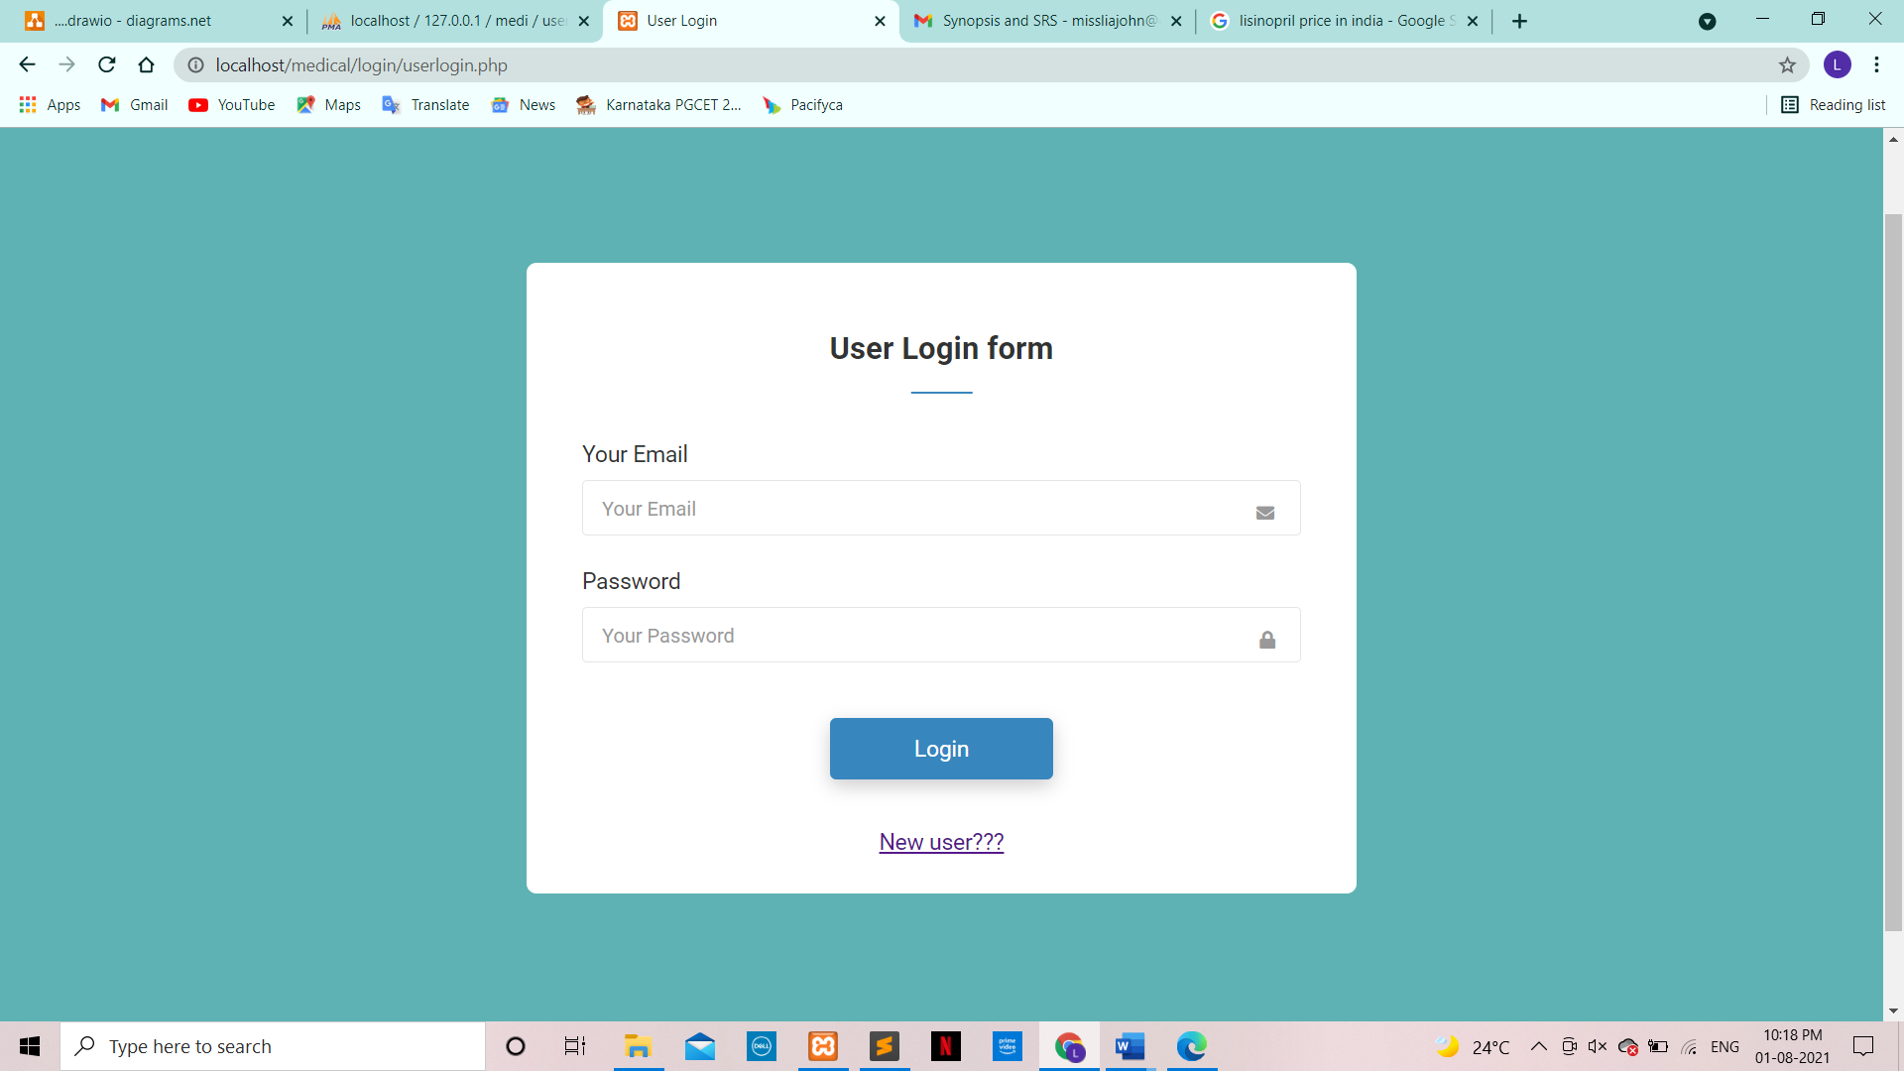

**USE:** This form enables an user to log into the website.

**User register form**

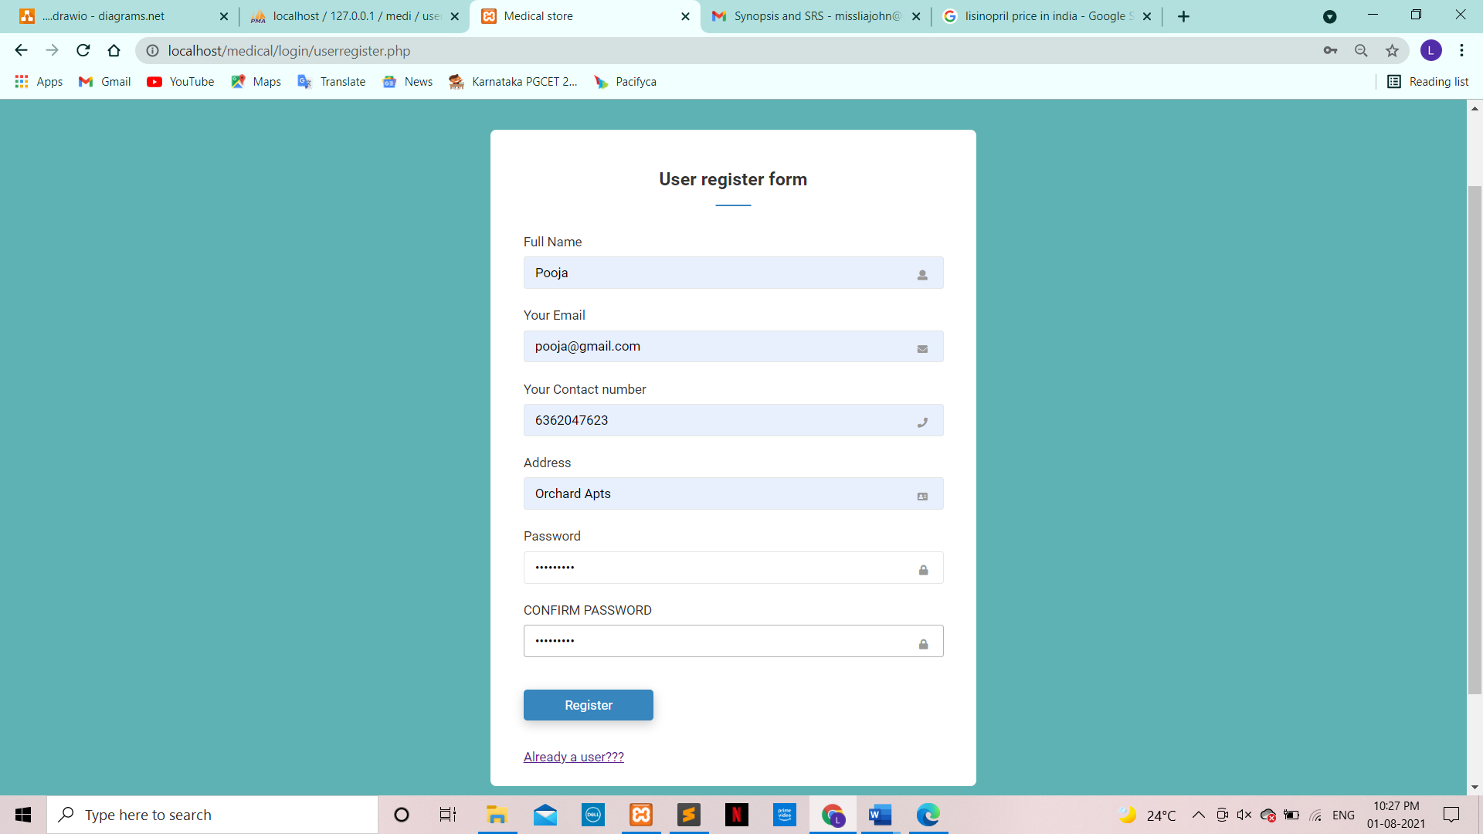

**USE:** This form allows a user create an account for ‘Ashirvad Medi Store’.

**Main page**

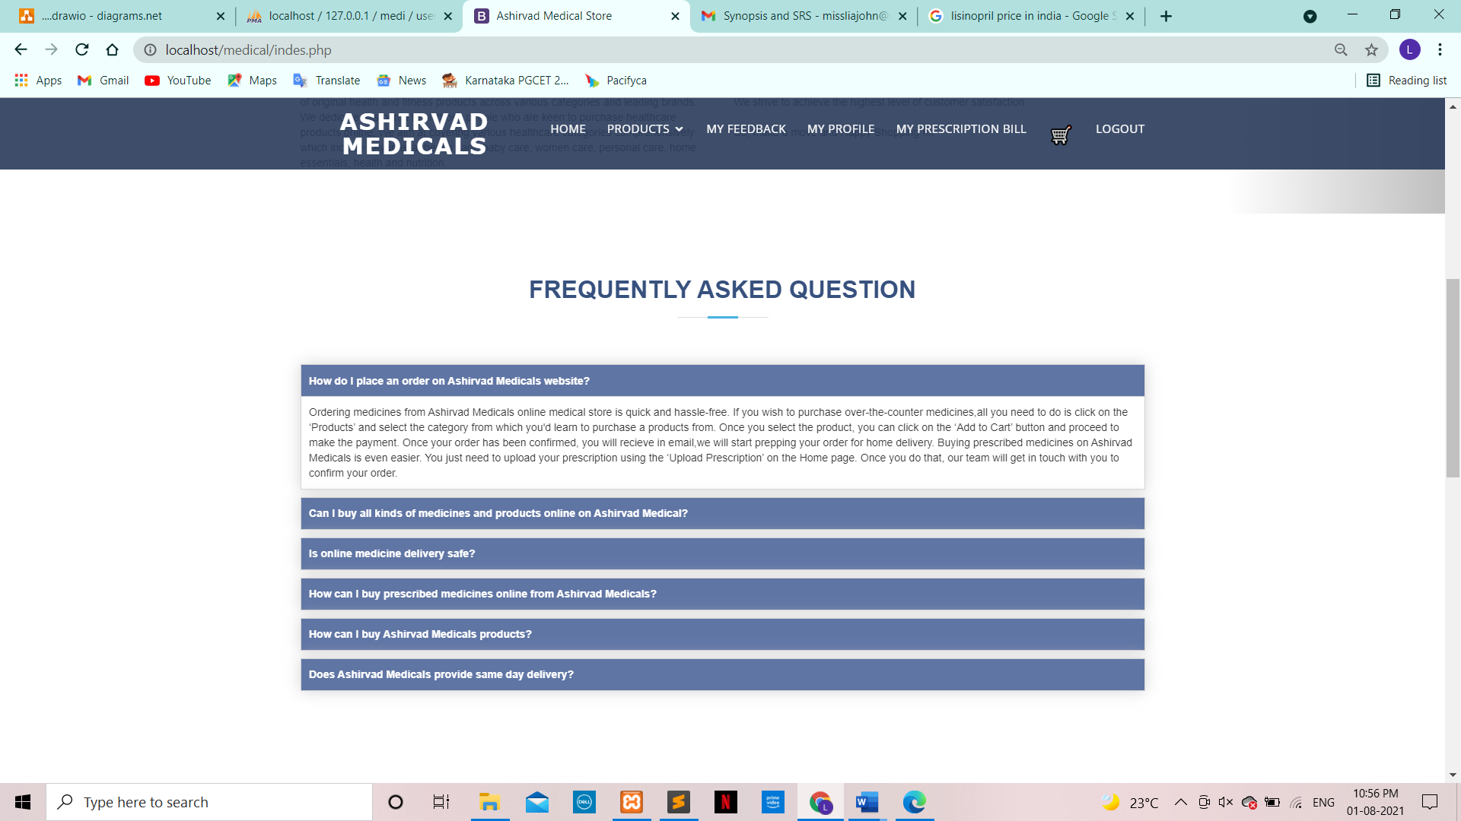

**USE:** FAQs allow customers to view the most commonly asked questions.

**Upload prescription**

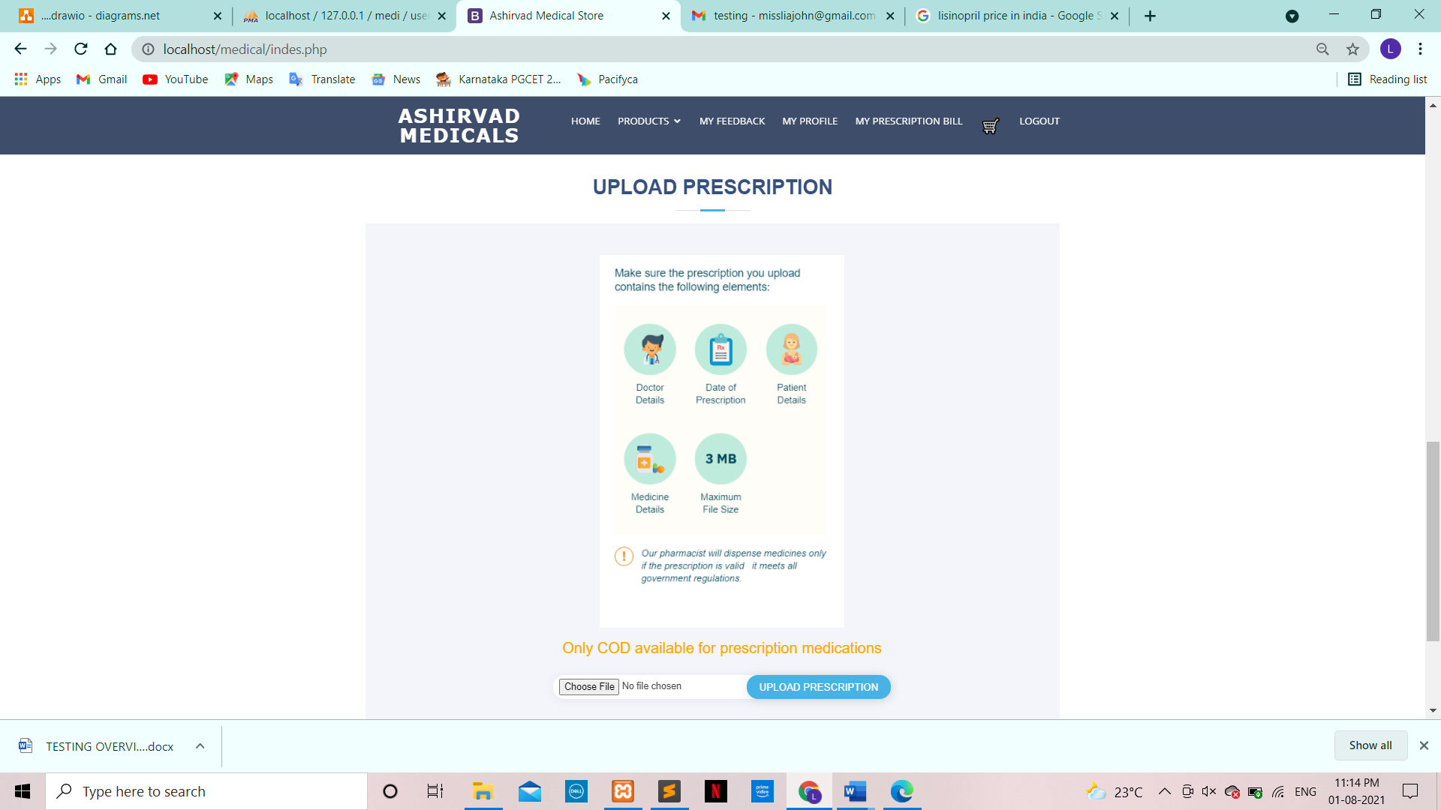

**USE:** The ‘upload prescription’ tab allows the user to upload a prescription image

**Upload prescription**

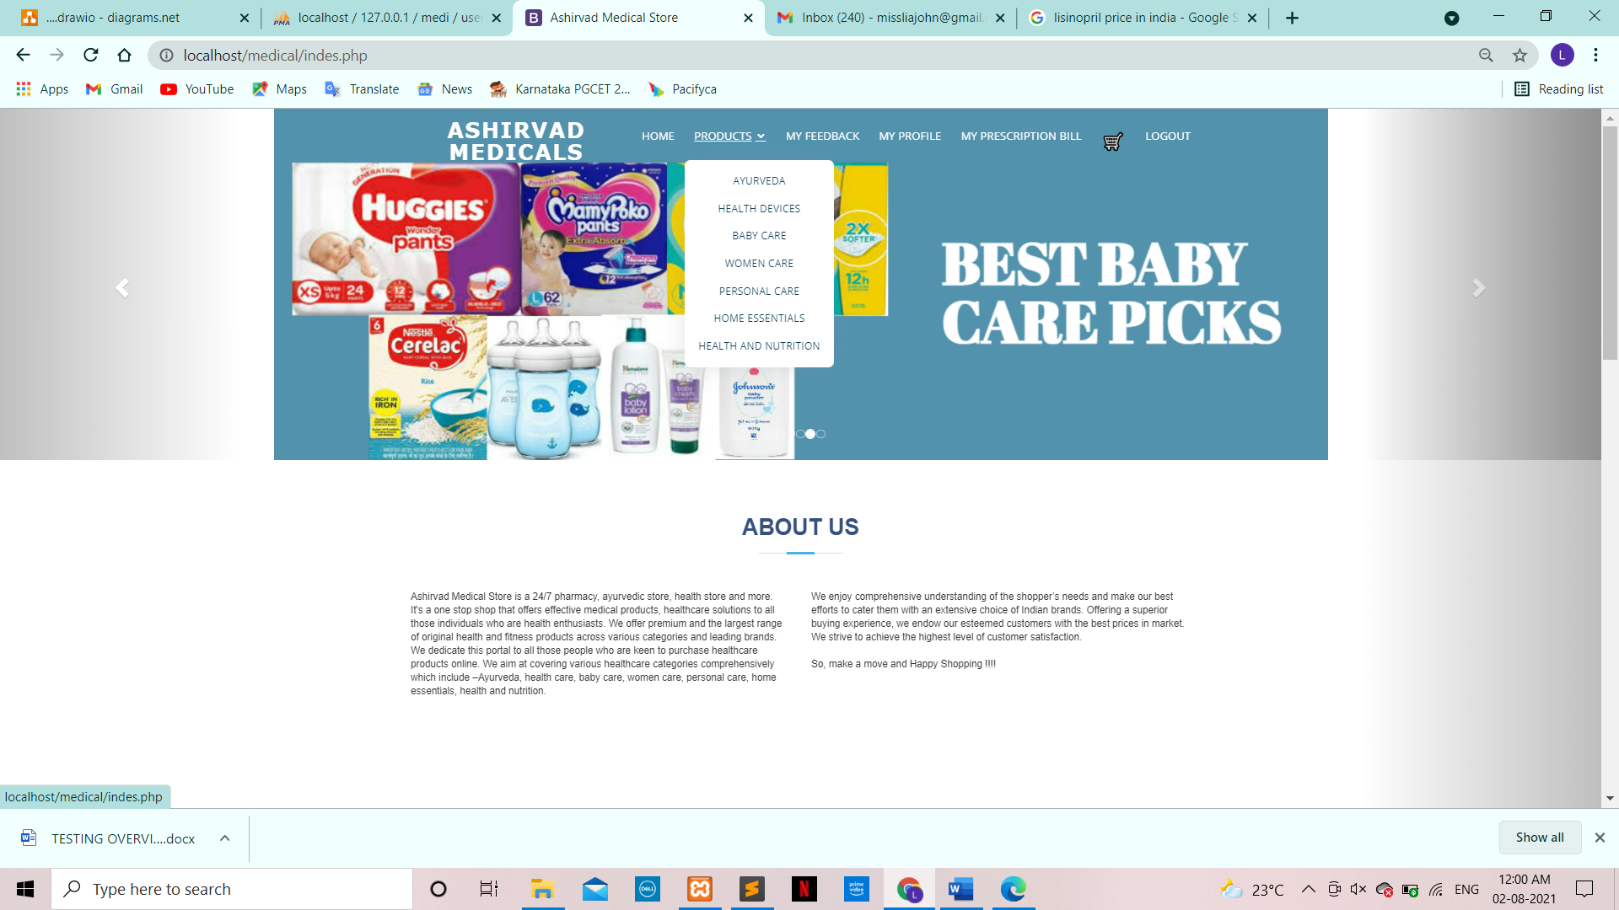

**USE:** The ‘products’ drop down, allows users to select a category from which they want to shop.

**Feedback**

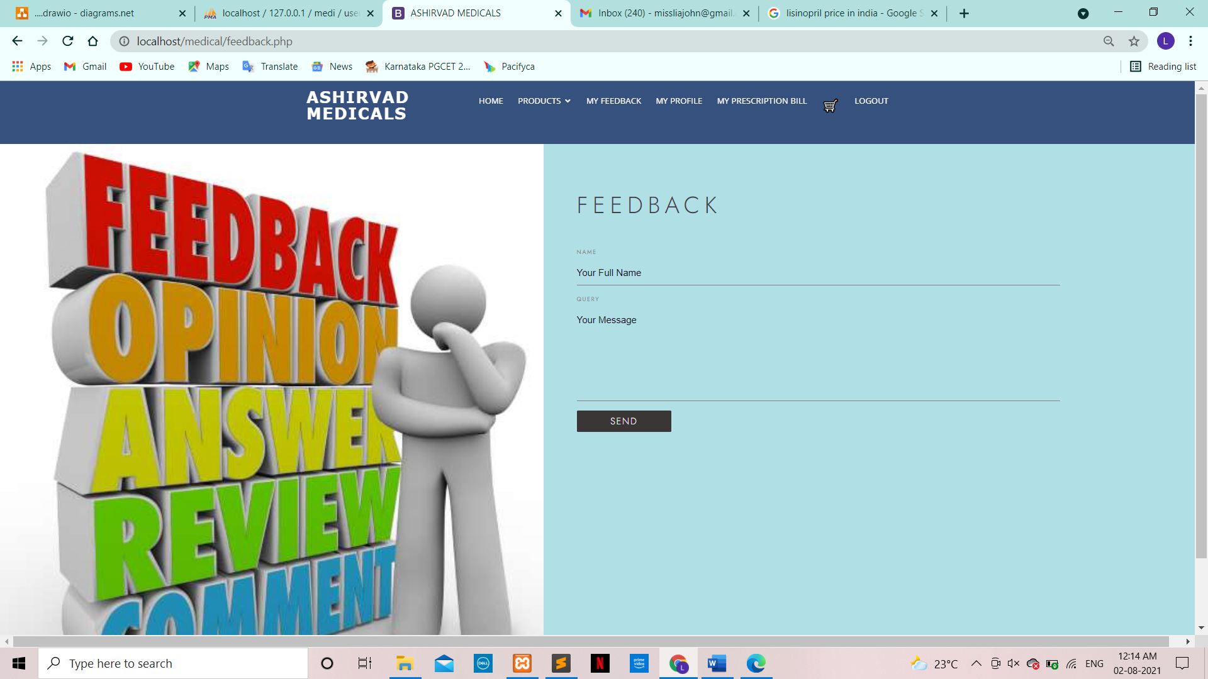

**USE:** The ‘feedback’ tab, allows users to send their feedback.

**My Profile**

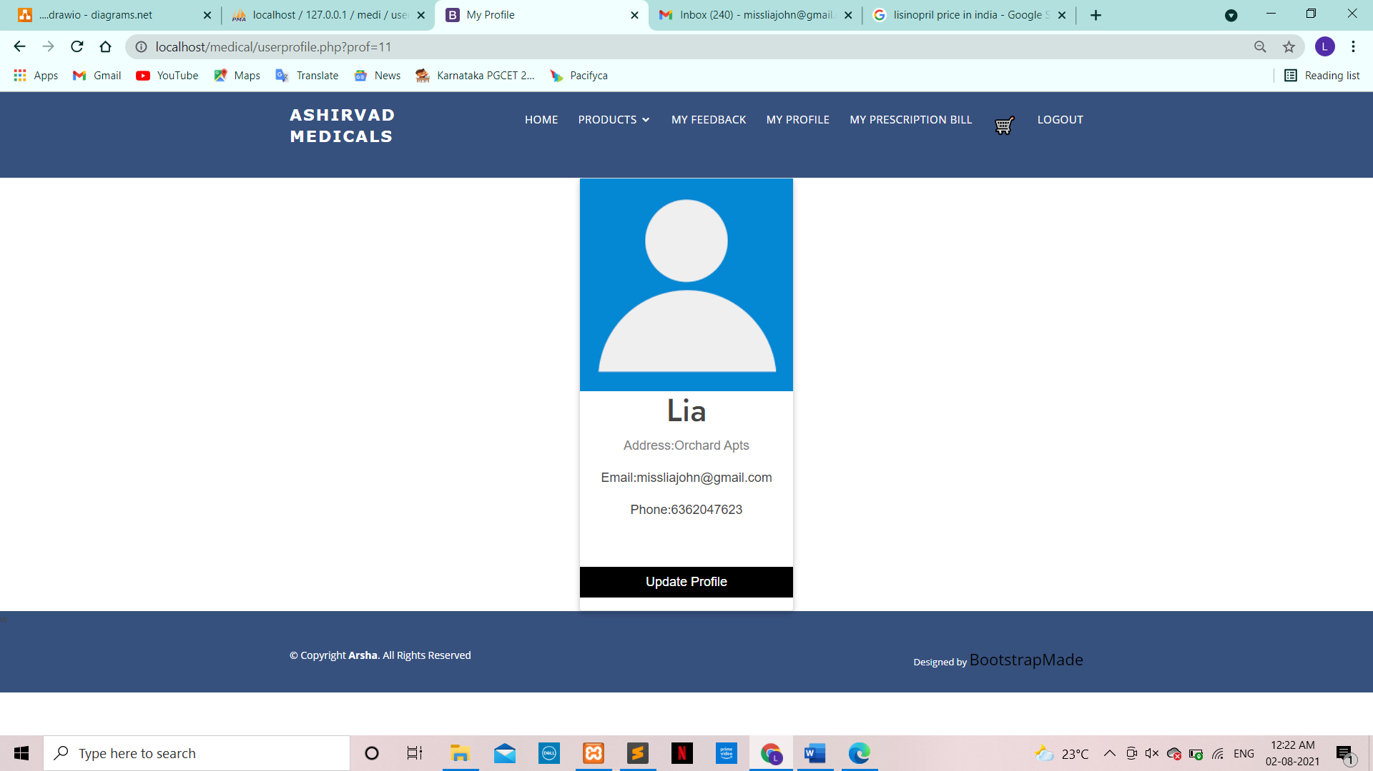

**USE:** The ‘My Profile’ tab, allows users to update their profile data.

**My prescription bill**

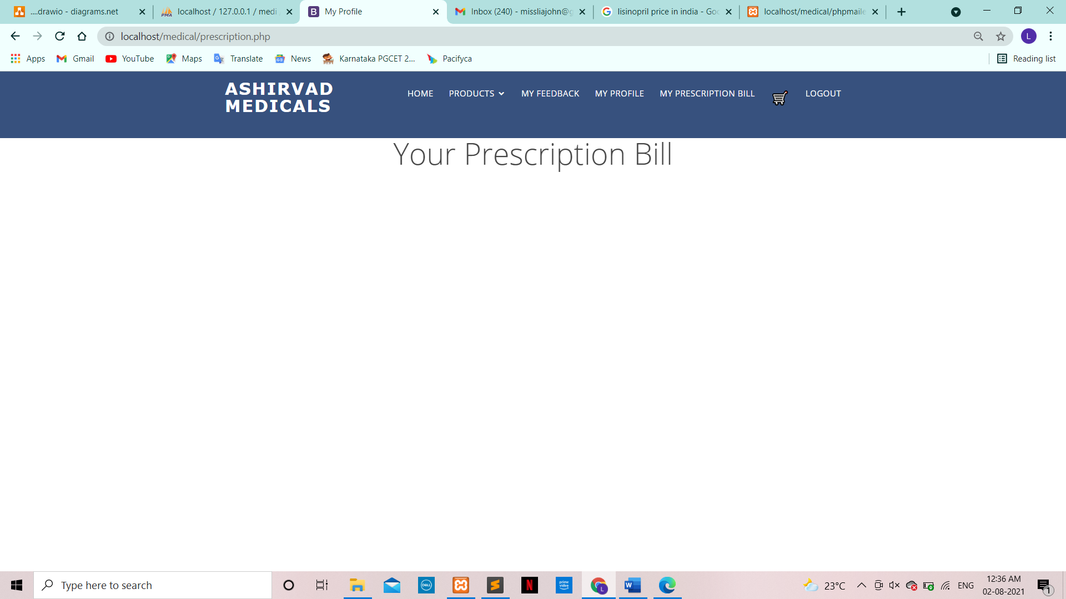

**USE:** The ‘My Prescription bill’ tab, allows users to download their prescription bill.

**Cart**

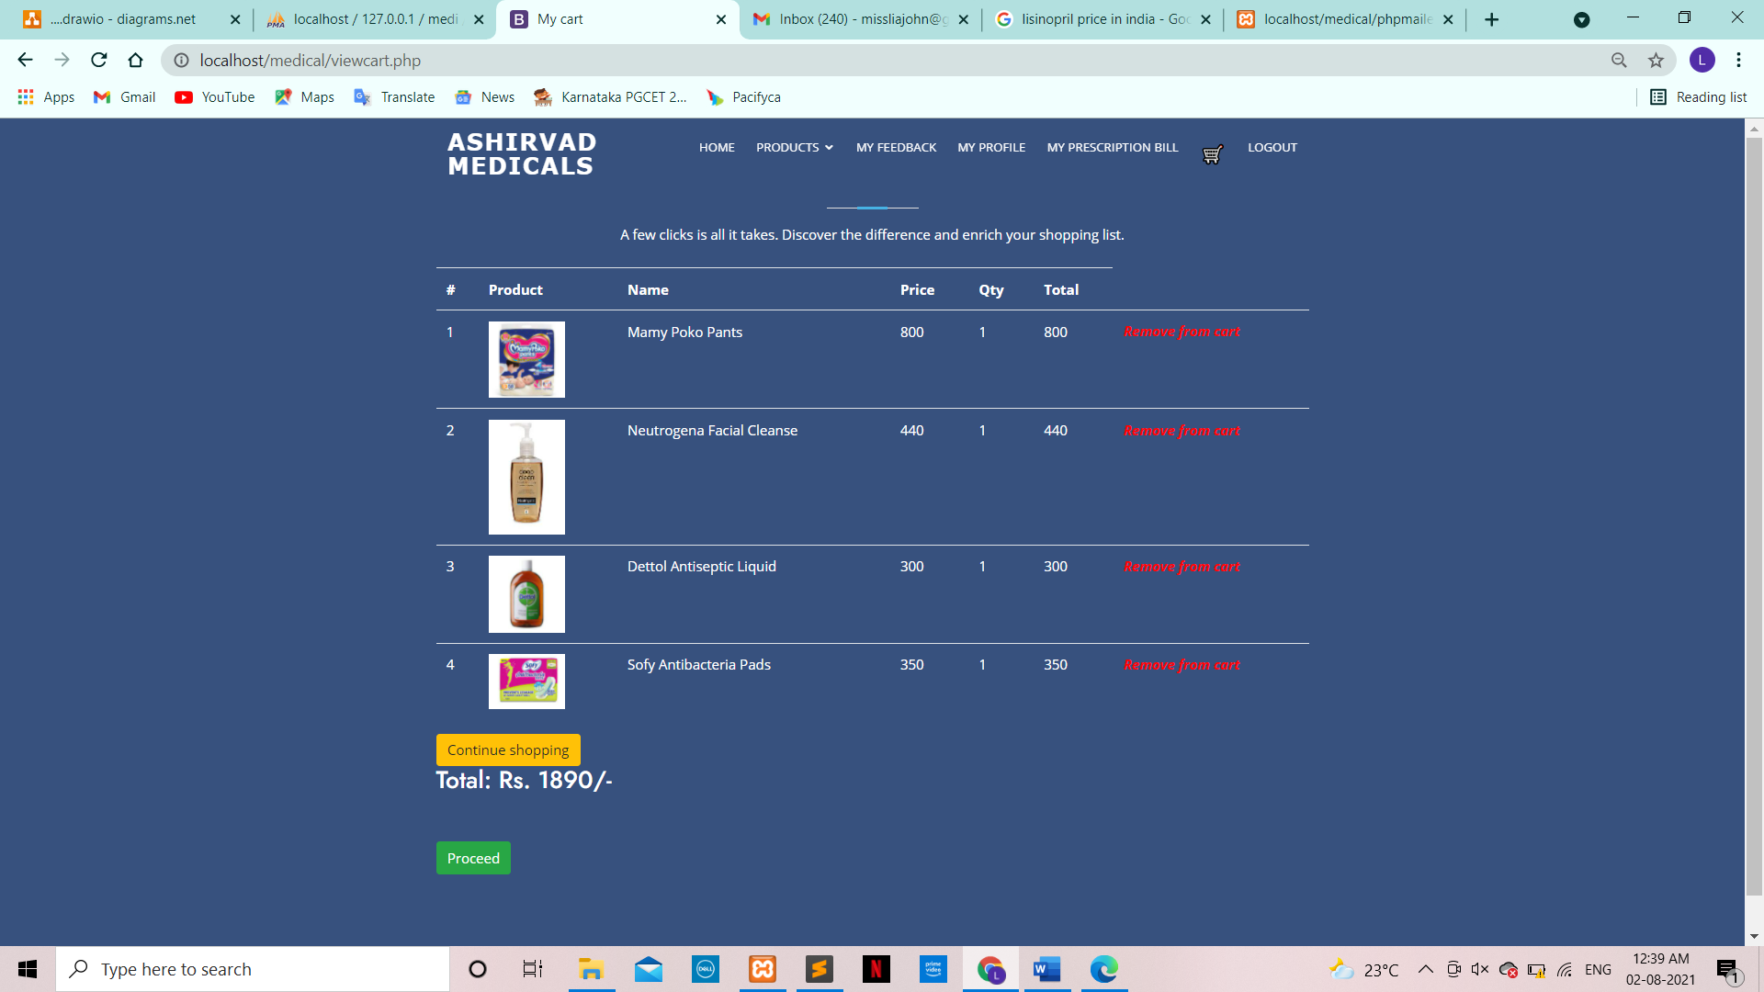

**USE:**

* The ‘Cart’ tab, allows users to view their order.
* A user can remove a product, continue shopping or proceed with the payement.

**Payment:**

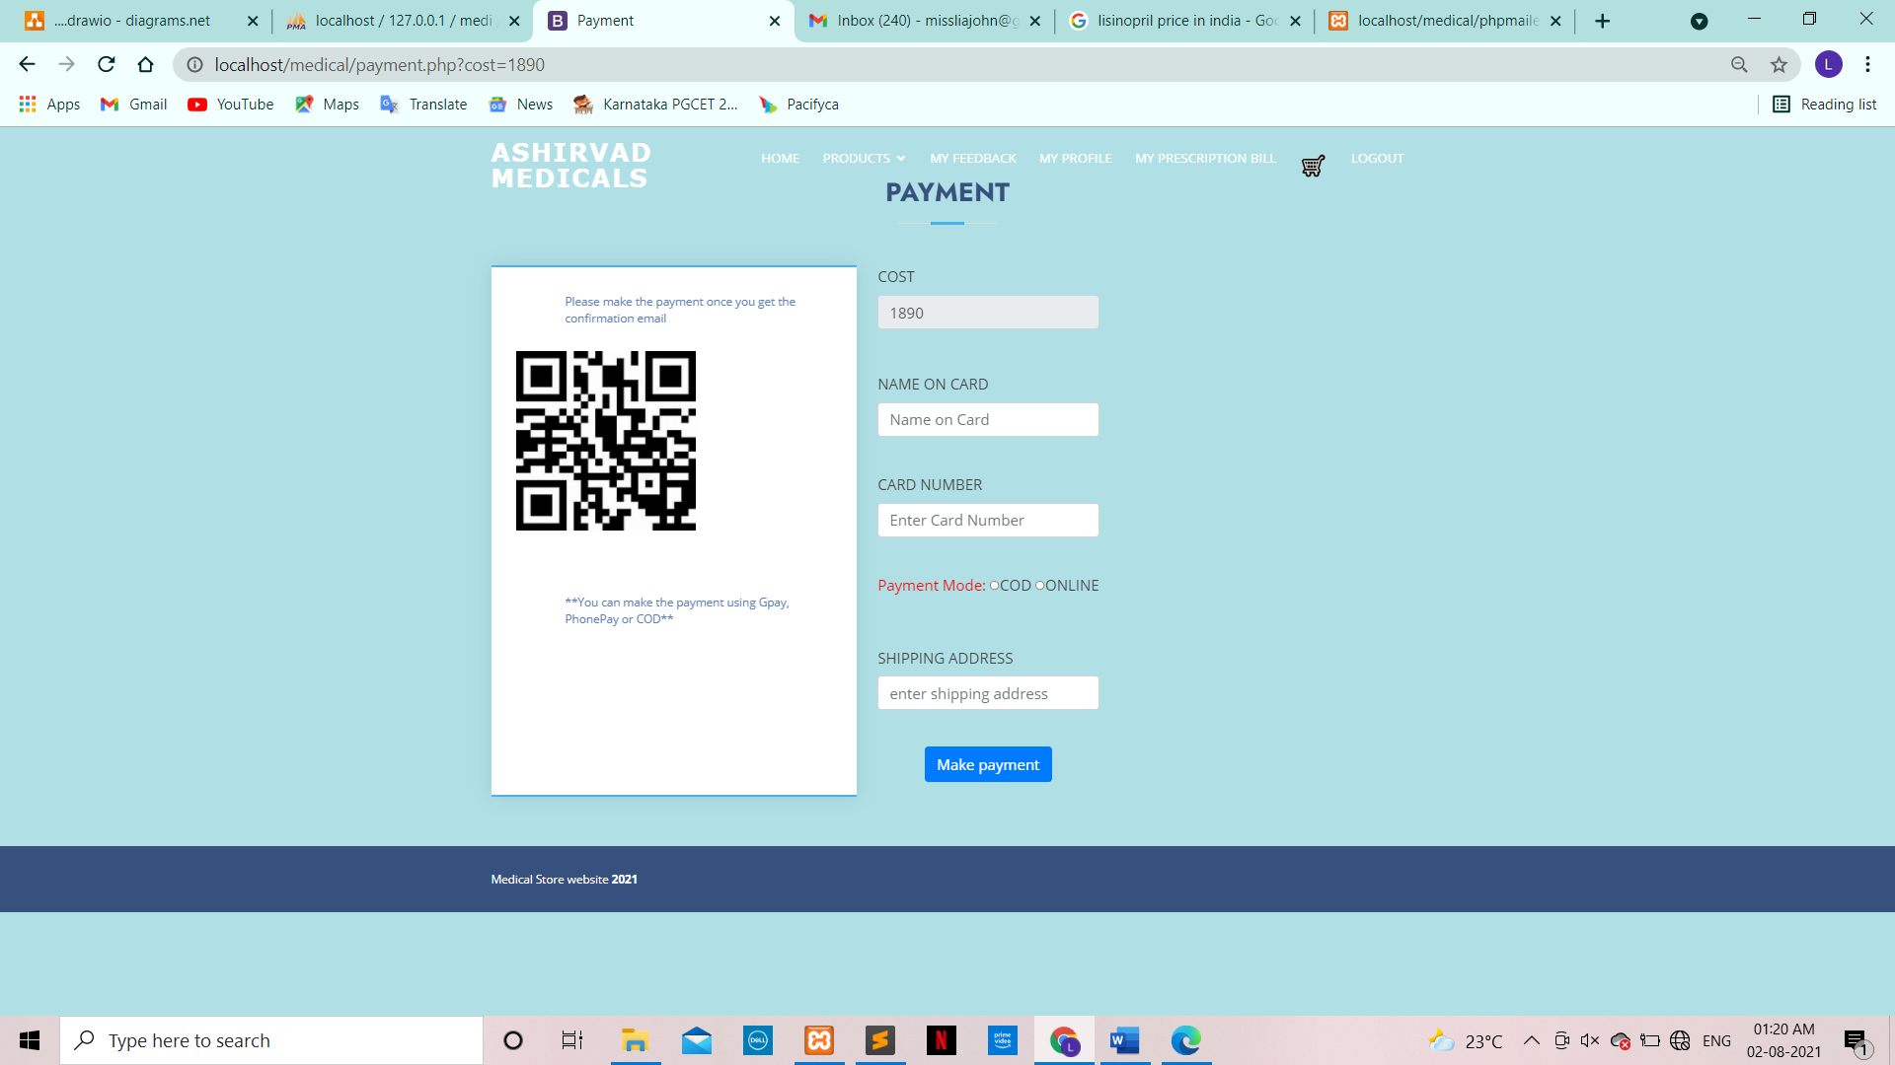

**USE:** The Payment tab is for the users to pay for their products.

**CONCLUSION**

**CONCLUSION**

The project titled “ASHIRVAD MEDI STORE” has been designed and developed in PHP. Many user friendly window controls are added to make it an interactive website. The project is tested successfully and a report is generated. This project has satisfied all the requirements. The website has been created in an attractive user interactive fashion. So any lay man can use this application with ease. This website has fulfilled all the objectives identified and provides an attractive user friendly interface. The reports requested by the user have been generated and all documentation required for operation and maintenance of the module has been provided.

**BIBLIOGRAPHY**

**Bibliography**

Learning PHP, MySQL, JavaScript and CSS: A Step-by-Step Guide to Creating to Dynamic websites by Robin Nixon.

**References:**

[www.w3schools.com](http://www.w3schools.com)

[www.tutorialspoint.com](http://www.tutorialspoint.com)